**Advanced tooling assignment-2 process and screenshots:**

Created itmdvm-521 directory In documents directory to store the virtual machines for this class with the command:

**mkdir itmdvm-521**

then I went into itmdvm-521 directory with the command: **cd itmdvm-521**

now we are in itmdvm-521 directory.

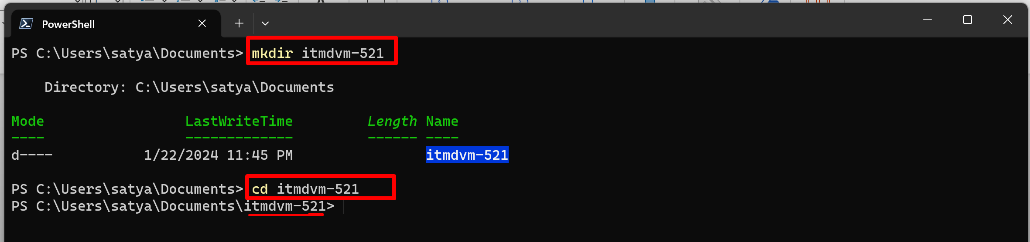

And I made 2 directories in itmdvm-521 and initiated virtual box and generated vagrant file with init command ~~~~~ the commands:

**mkdir jammy64 ; cd jammy64 ; vagrant init ubuntu/jammy64 ; ls**

**mkdir almalinux9 ; cd almalinux9 ; vagrant init almalinux/9 ; ls**

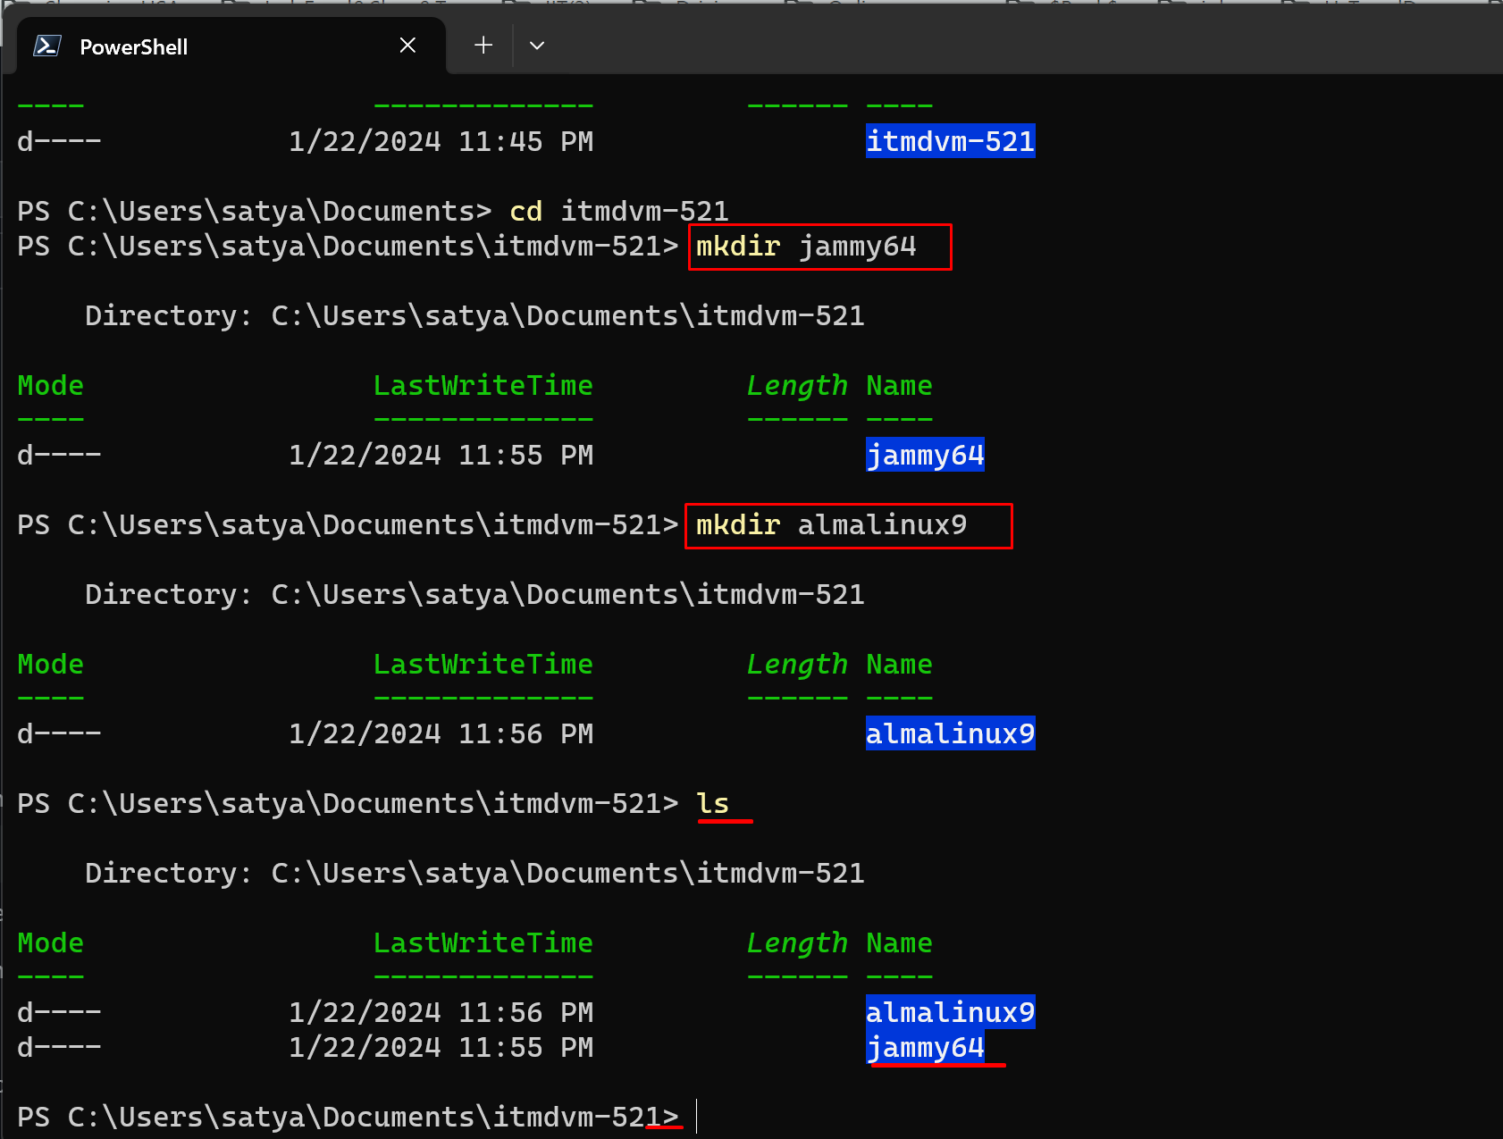

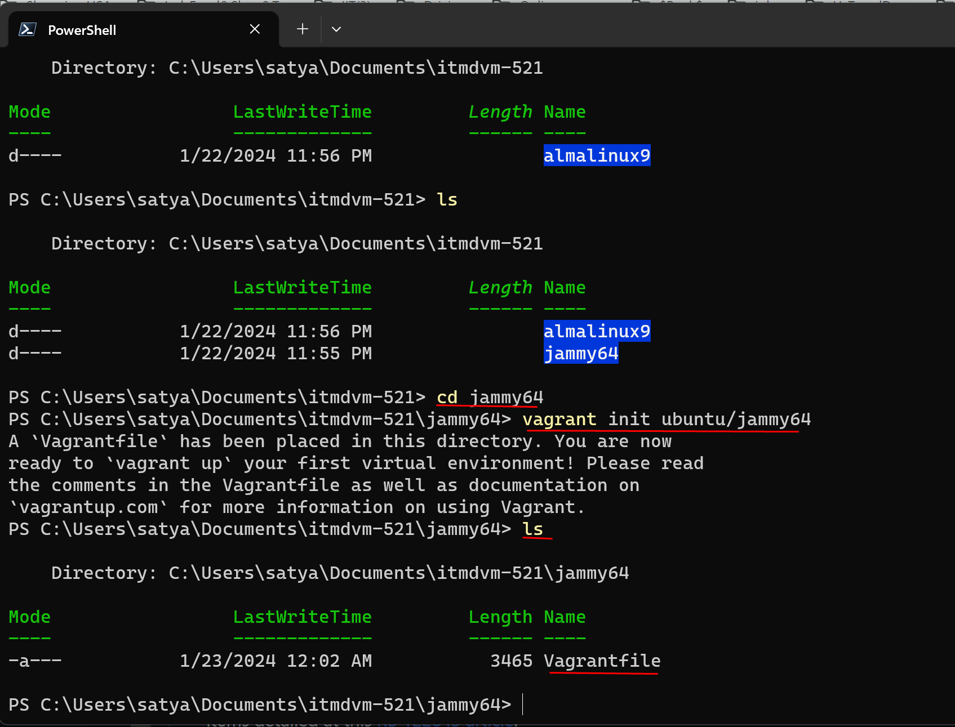

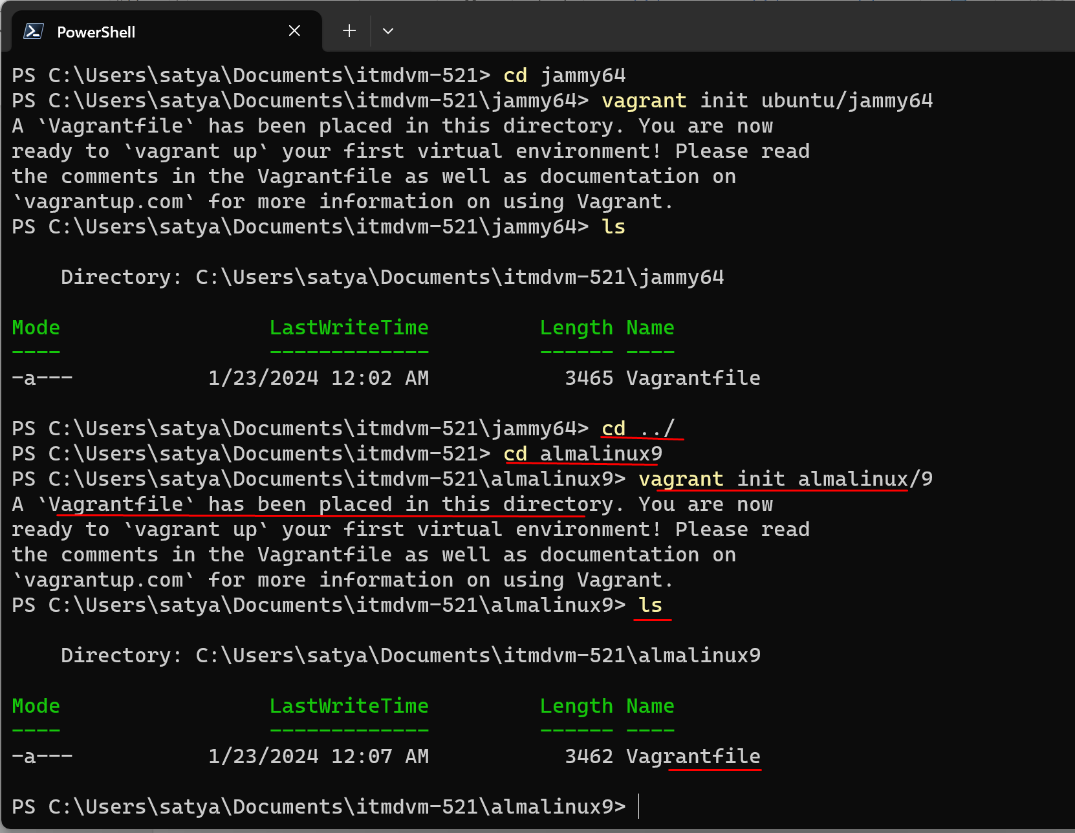

If we want to we can do **code Vagrantfile** to read the filejust like that and observe line 15

**LETS START VAGRANT BOX:**

We will do in jammy64

So we will go into jammy64 from almalinux with this commands

**cd jammy64**

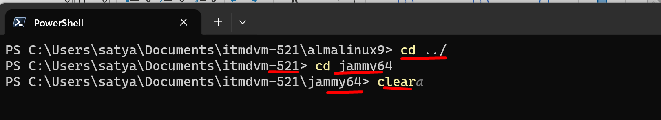

Then I did **vagrant up** in jammy64 to start the vagrant box. (if you see in virtual box it will be powered off)

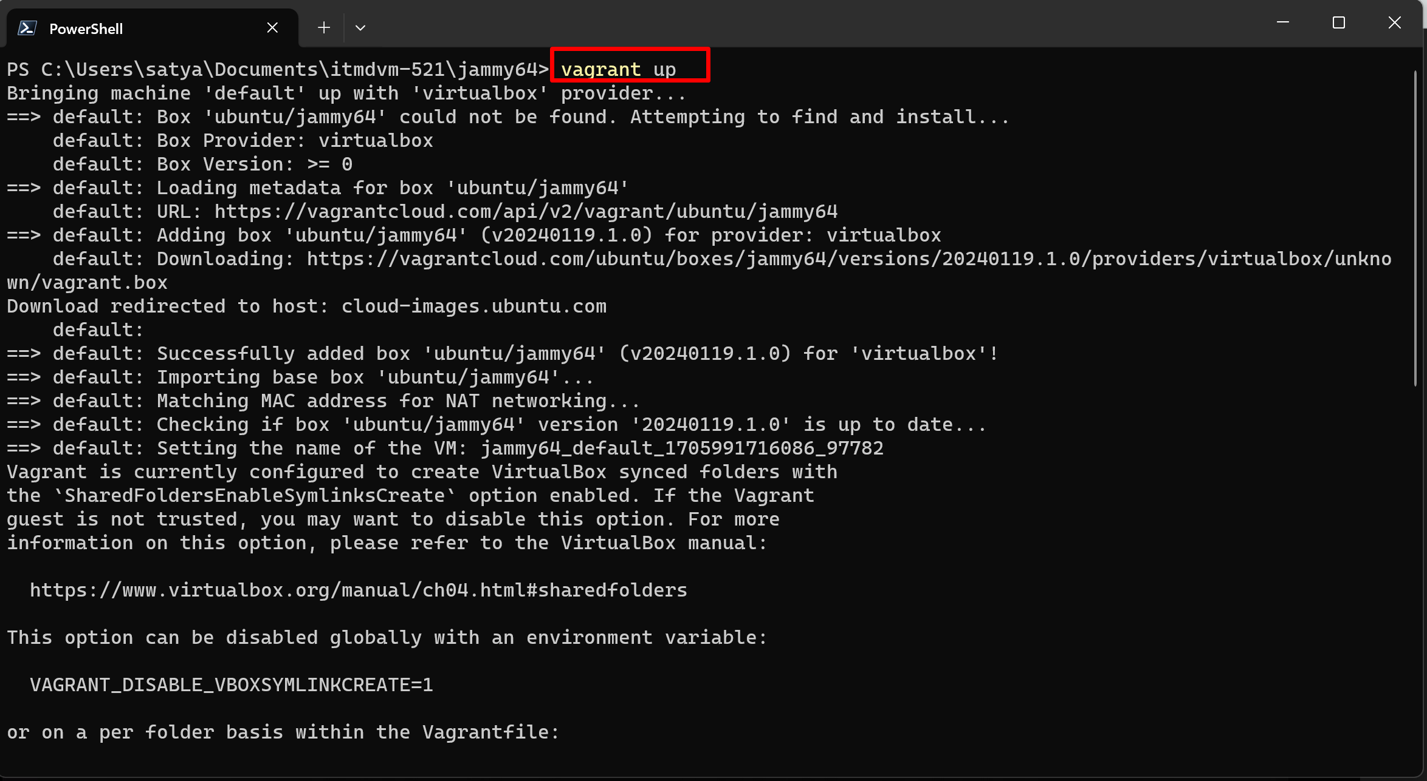

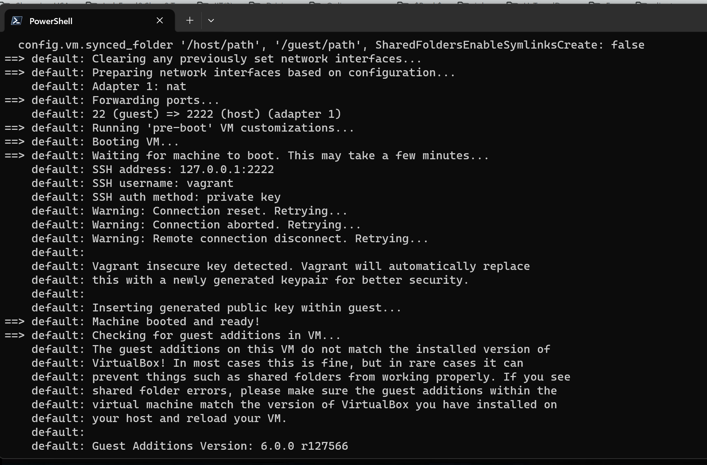

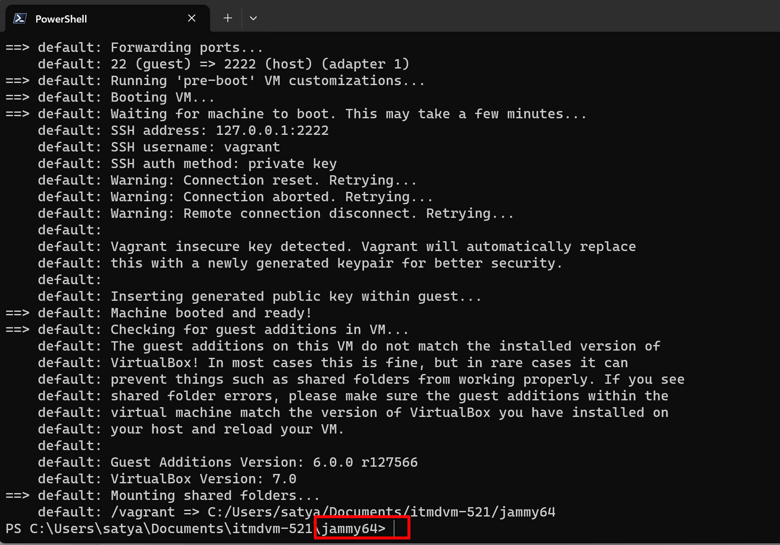

Then I did **vagrant** ssh in jammy64

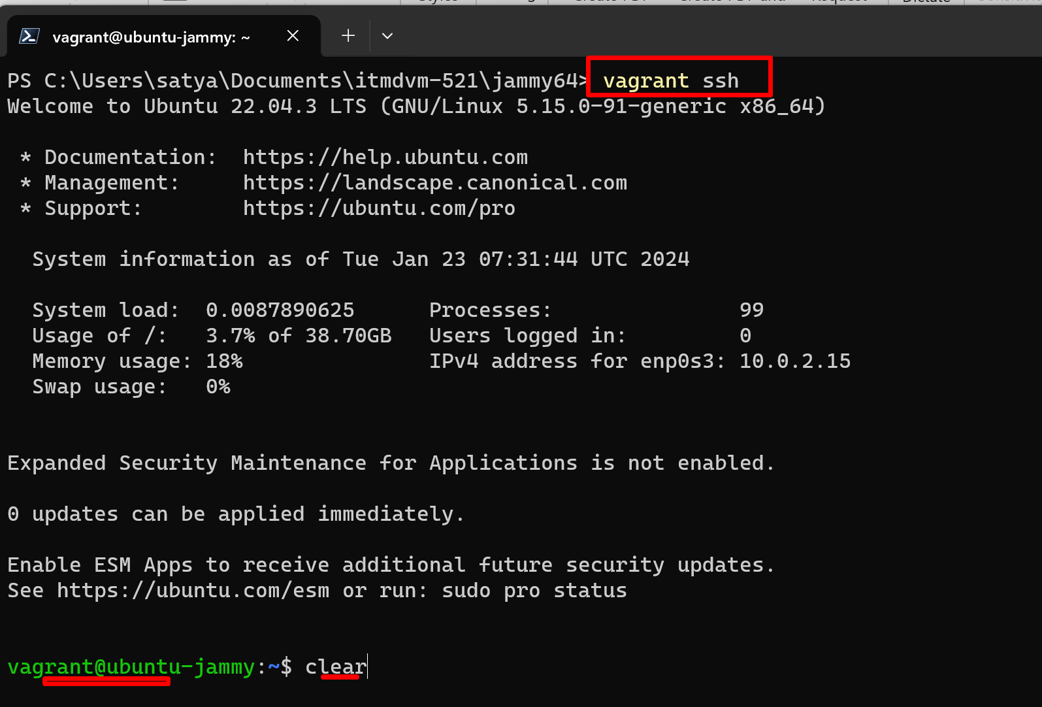

Then I did sudo apt update in jamy64 to update package managers

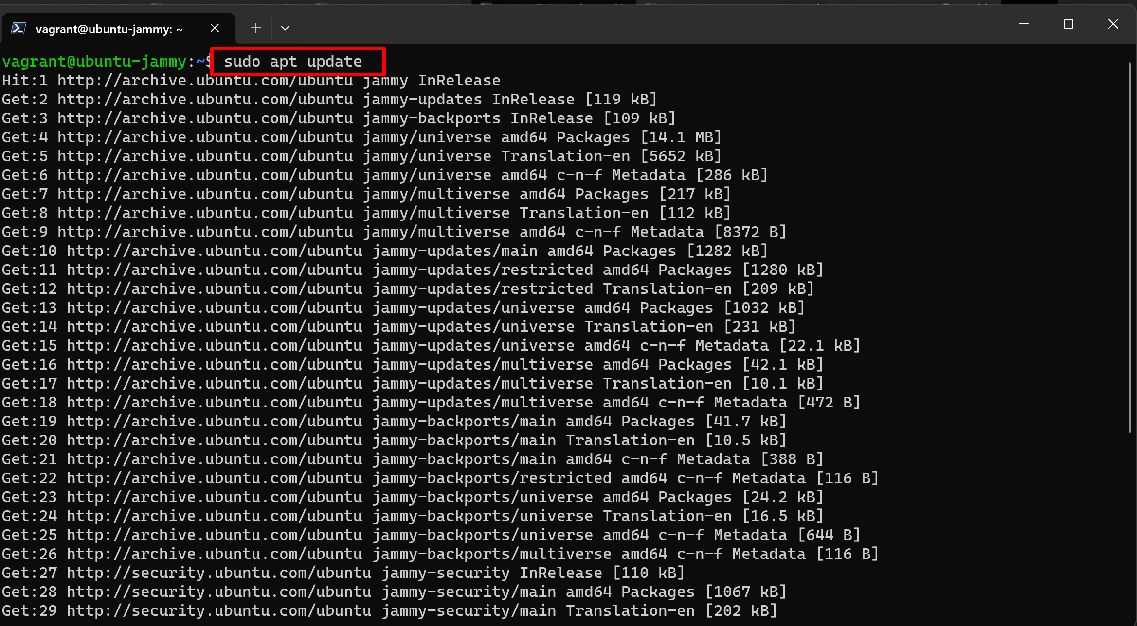

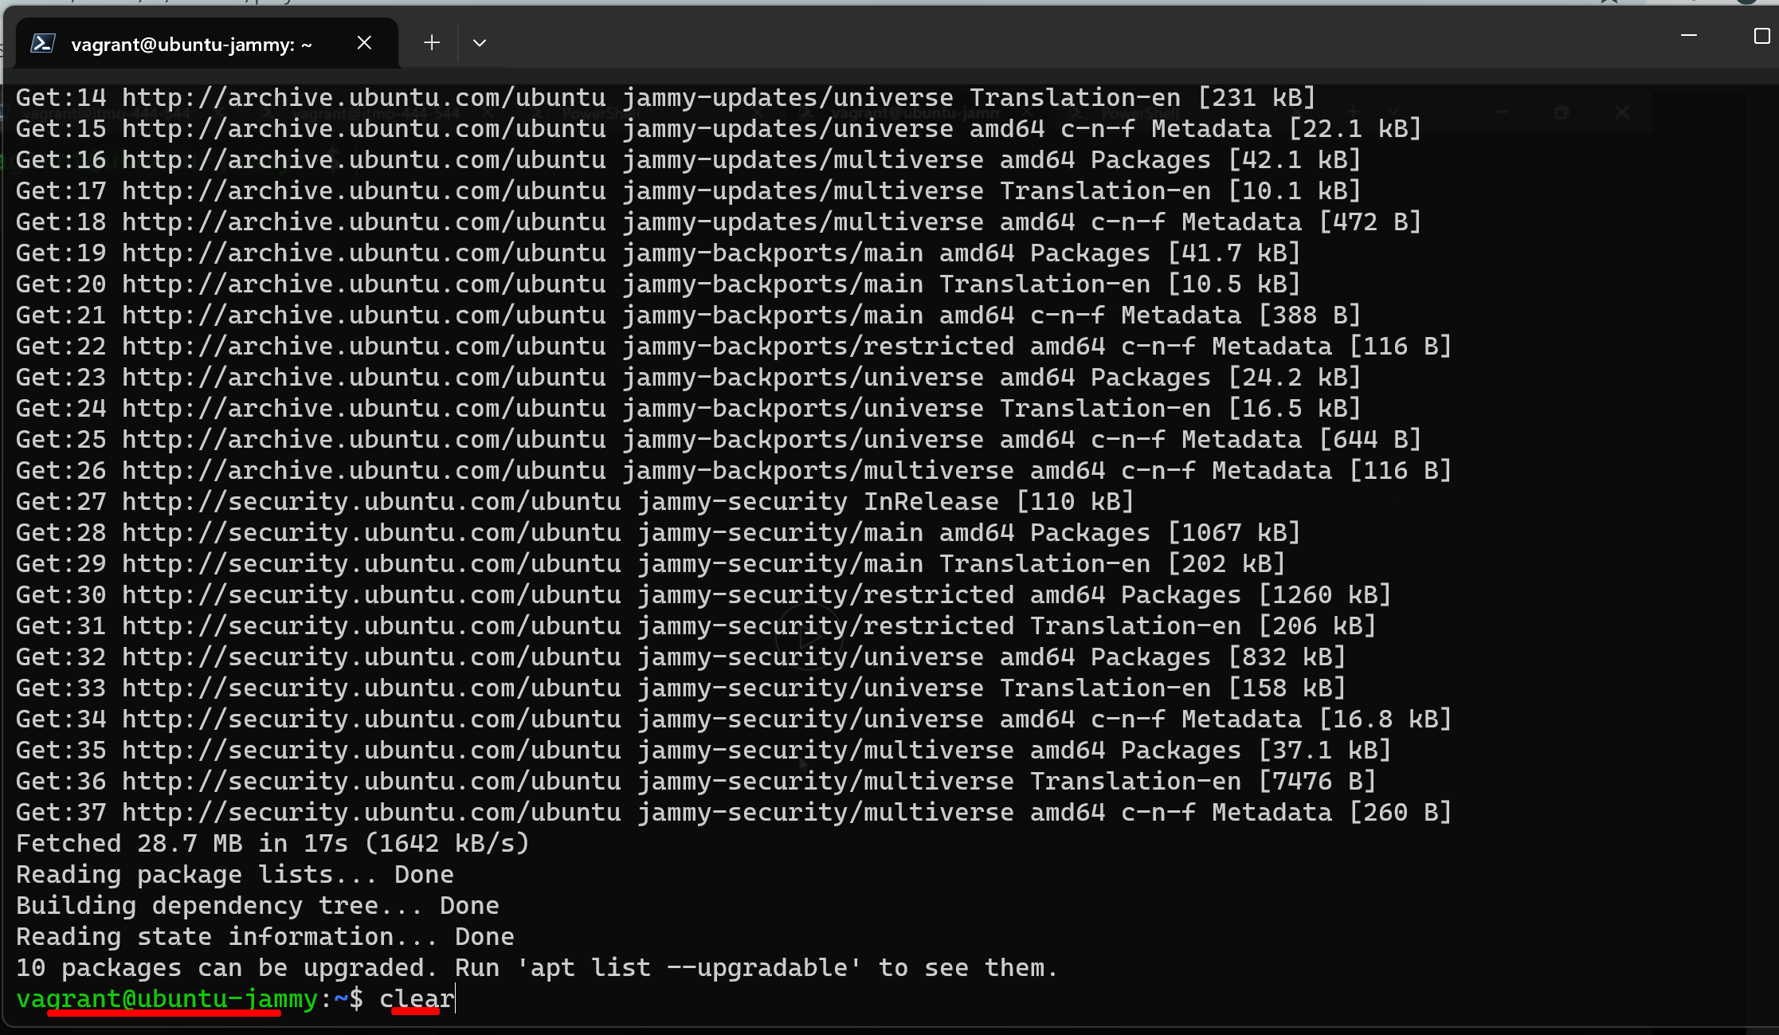

Do vagrant box list in jammy64 or in documents or itmdvm-521

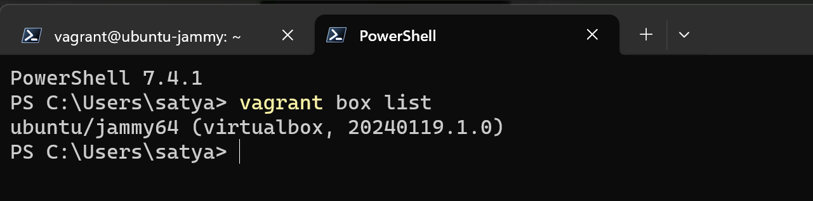

**Now Setting up a hot network:**

To do that exit the ssh session with **exit** command

And in jammy64 do

**code Vagrantfile**

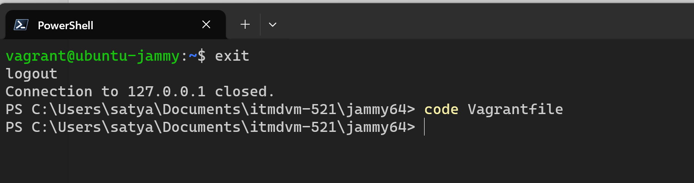

Then I uncommented line 35, 59, 64, 65 changed memory top 4 gigs….Save the file (cntrl S)

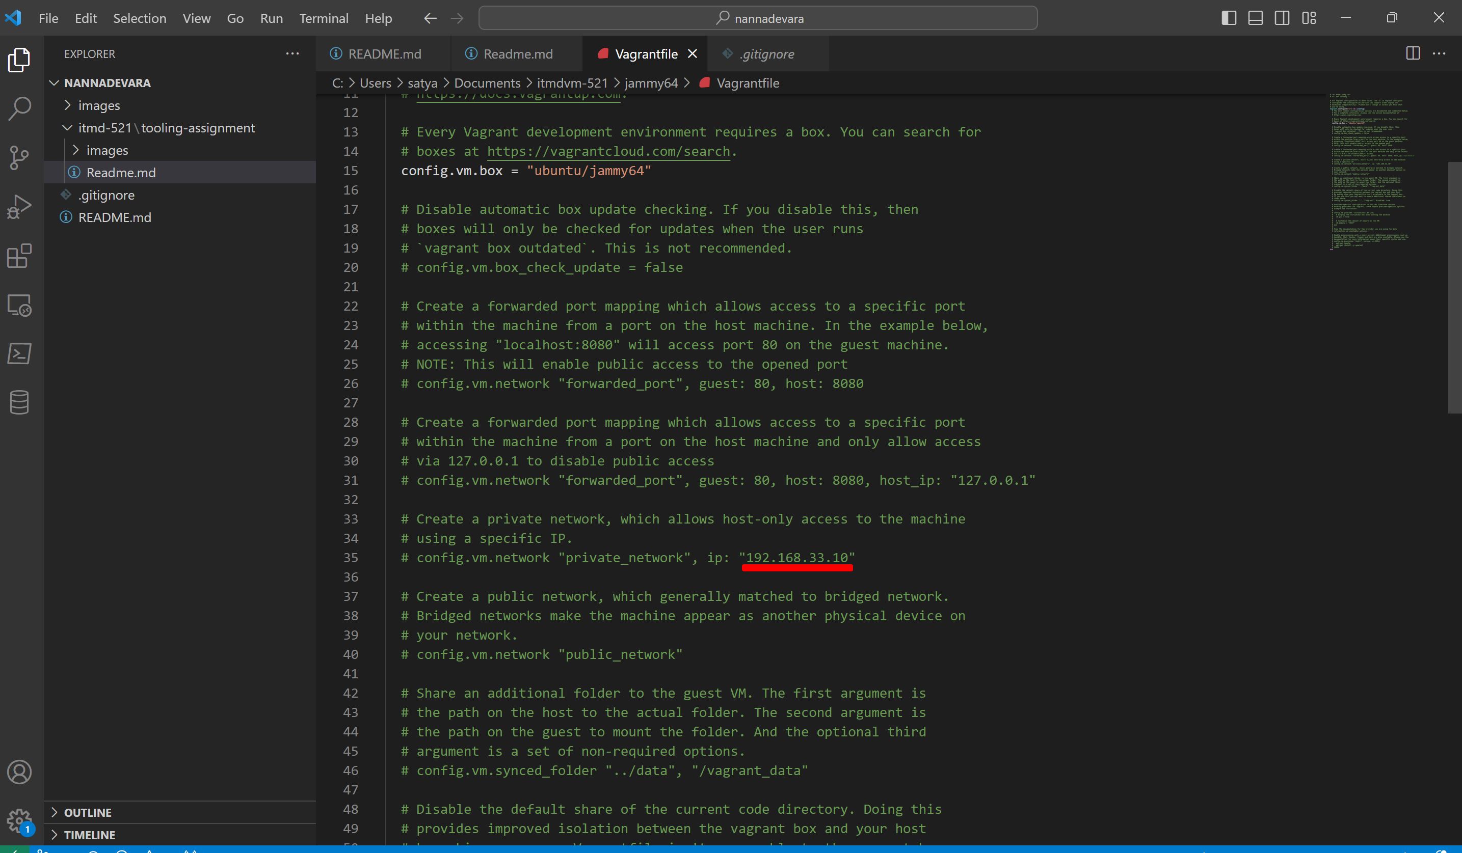

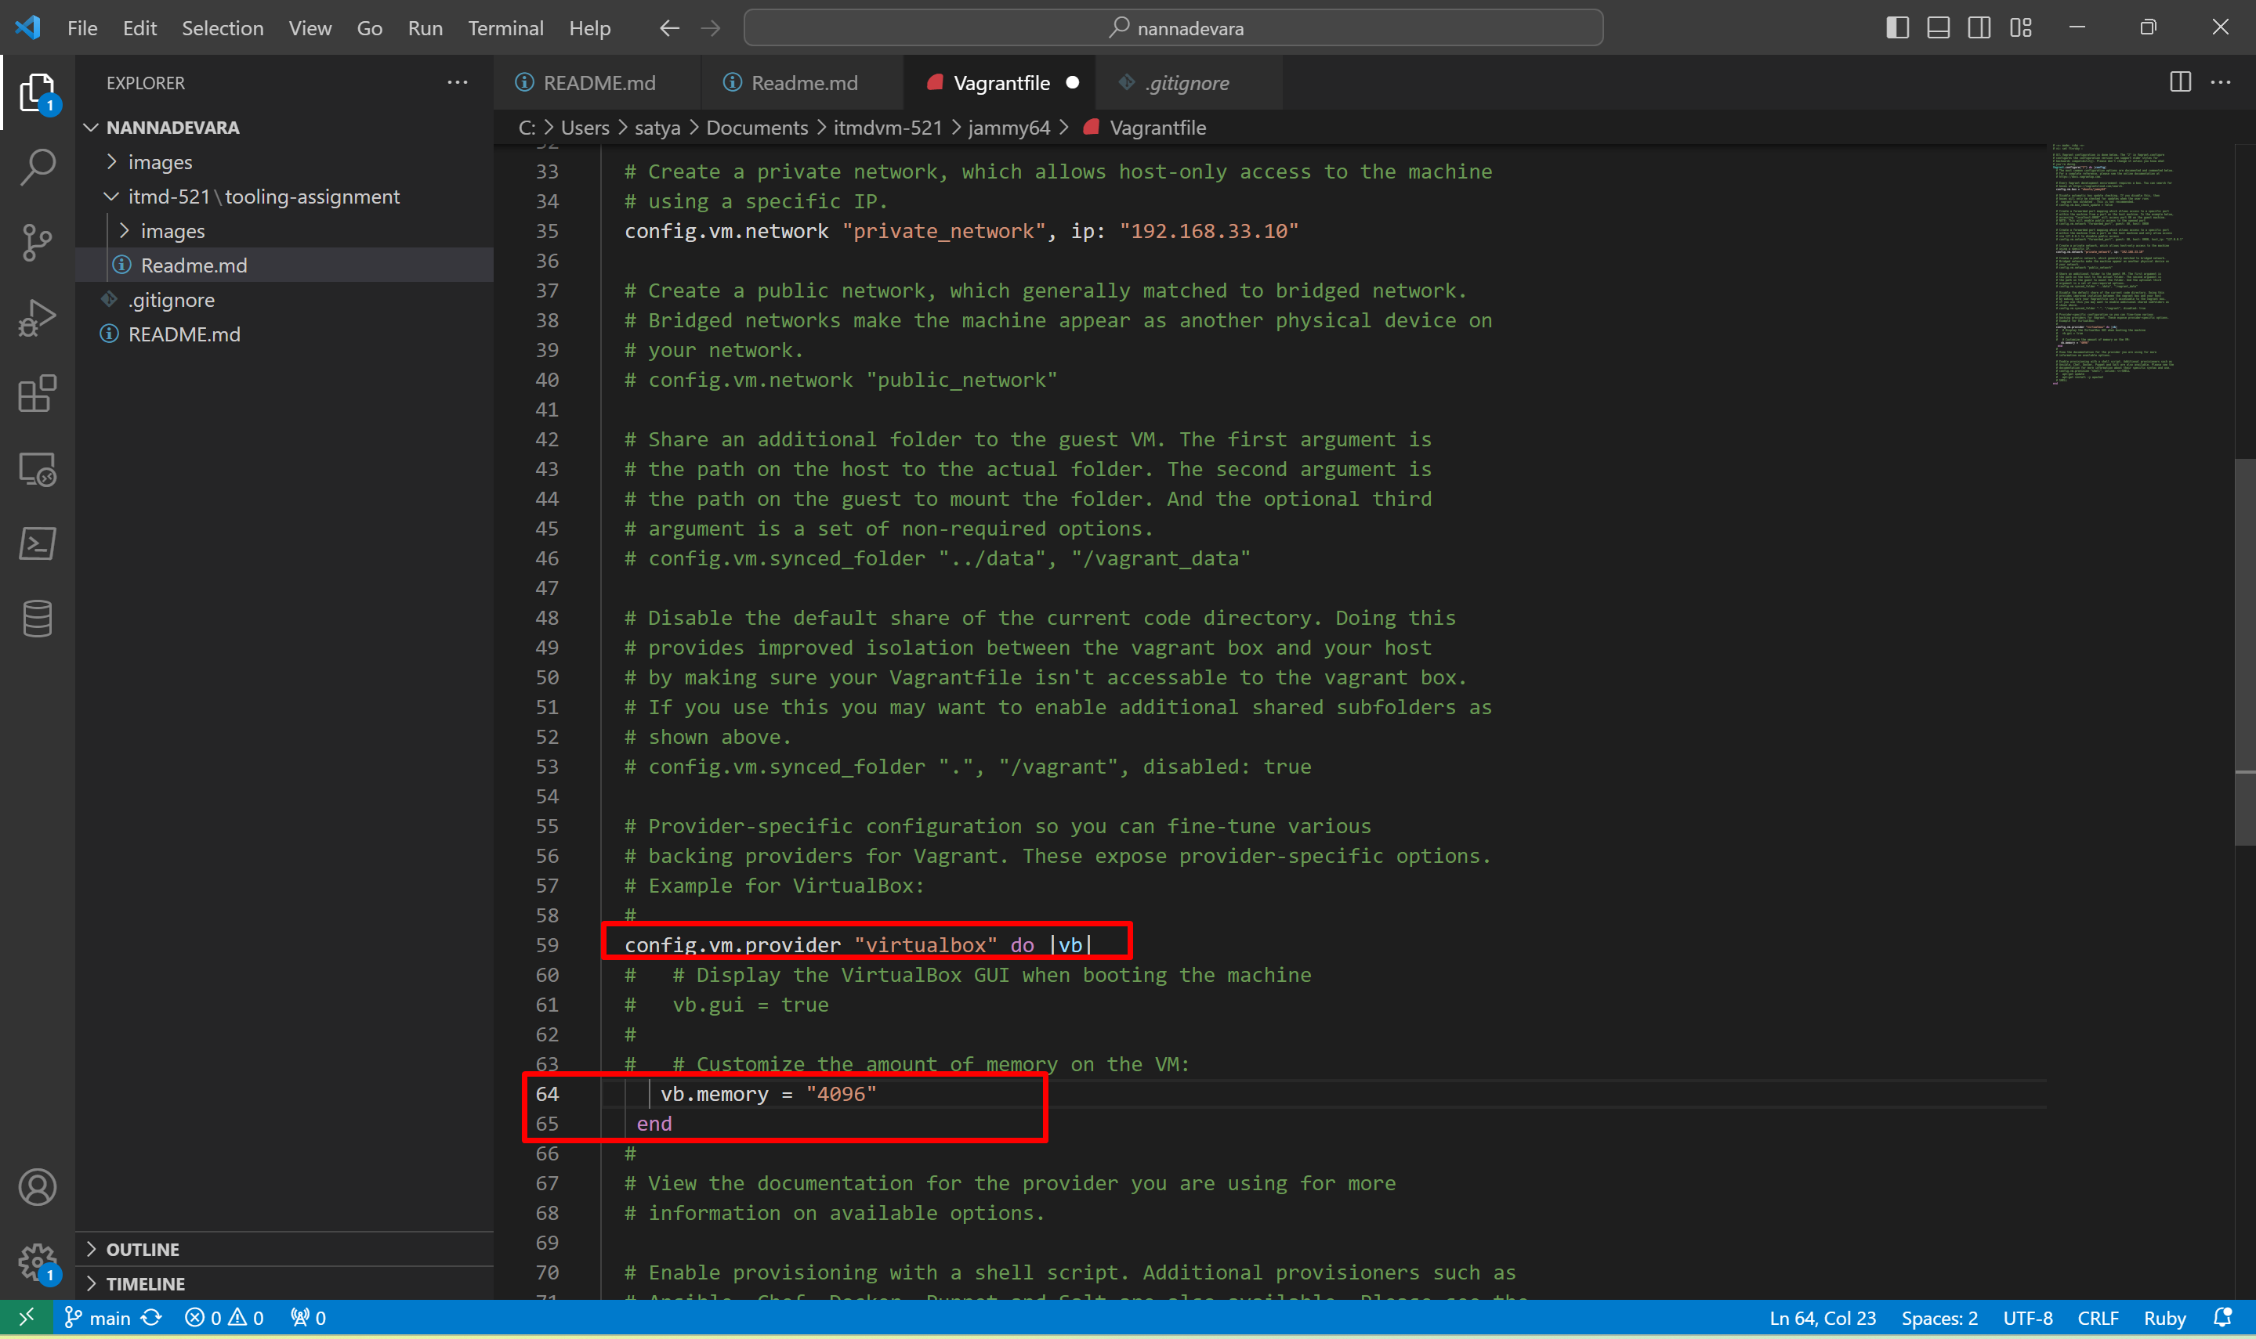

Now if jammy64 is running , do **vagrant reload --provision** or if powered off **vagrant up –provision**

I did is **vagrant reload –provision** in jammy64

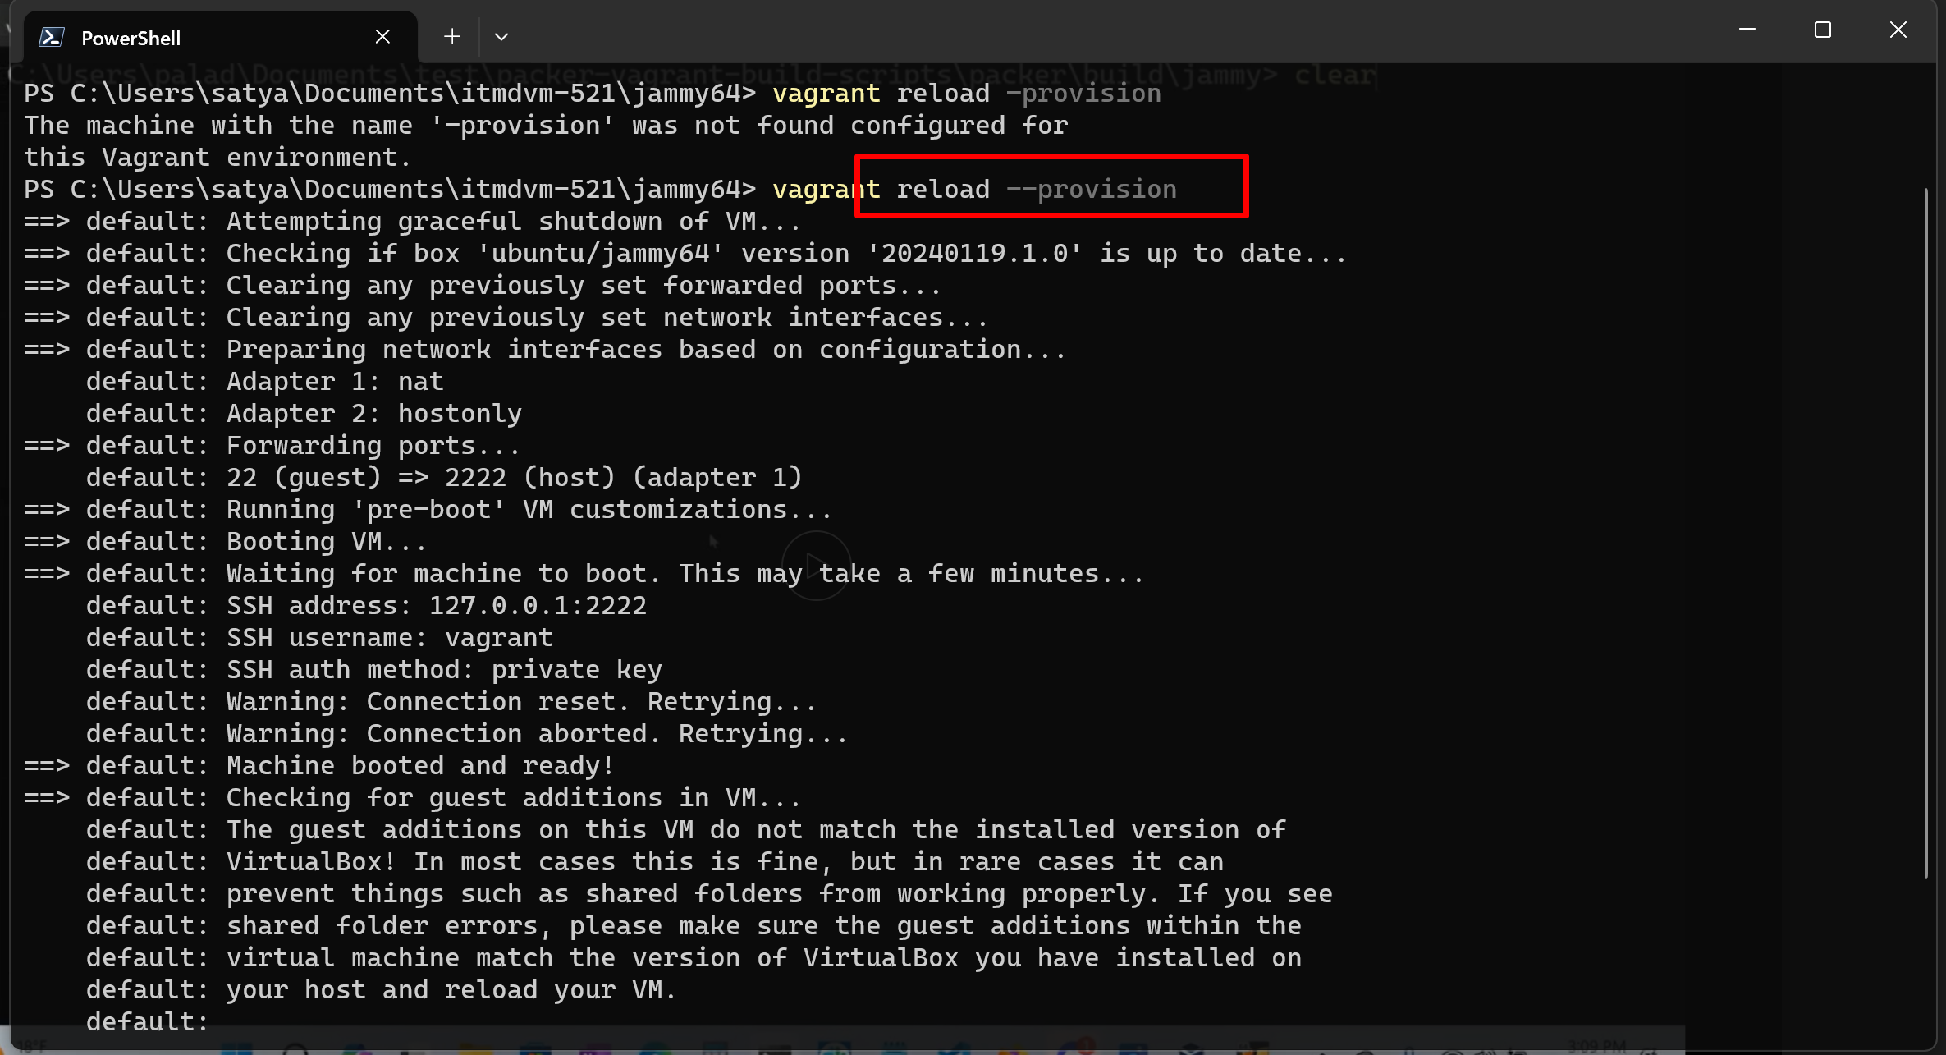

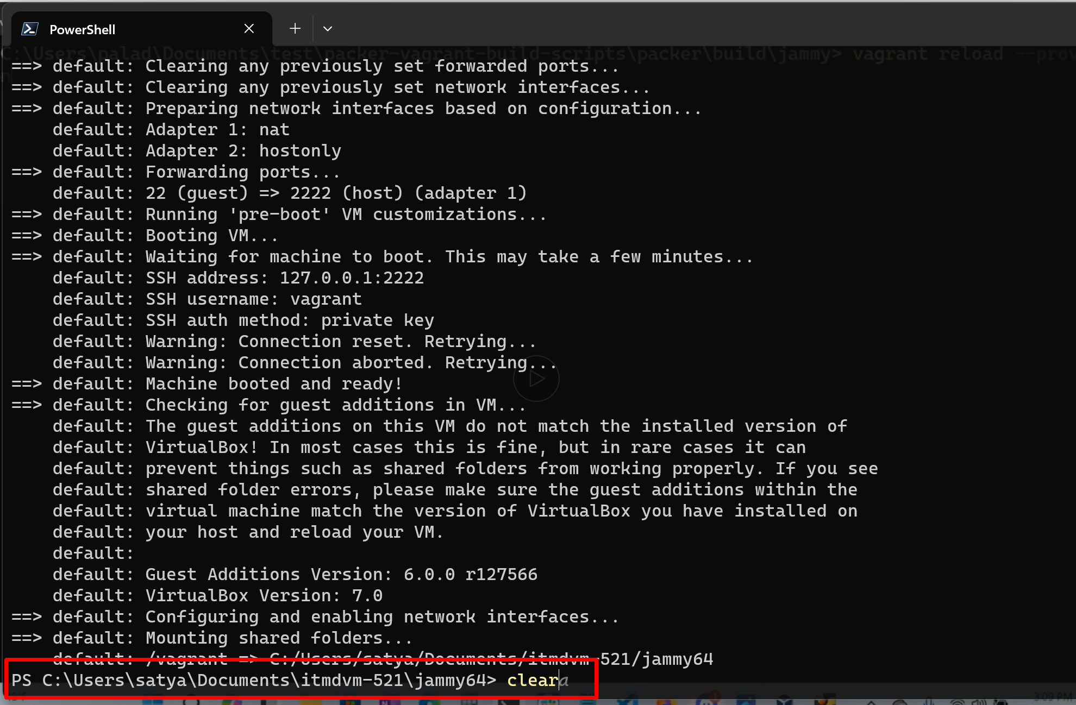

Now I connected again with **vagrant ssh** in jammy64 (we don’t do vagrant up bcoz we already started that’s why we are in jammy64) this is the our host only ip address ~ same withthat vagrant file ipadress

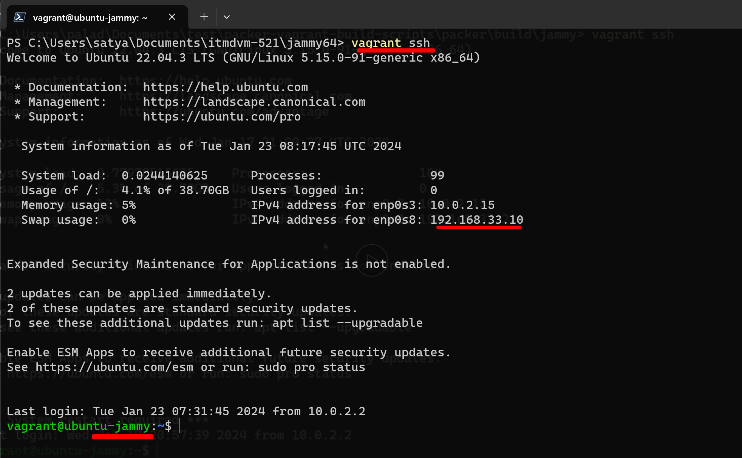

Then I did **sudo apt update** (which is the 1st command to check for updates)

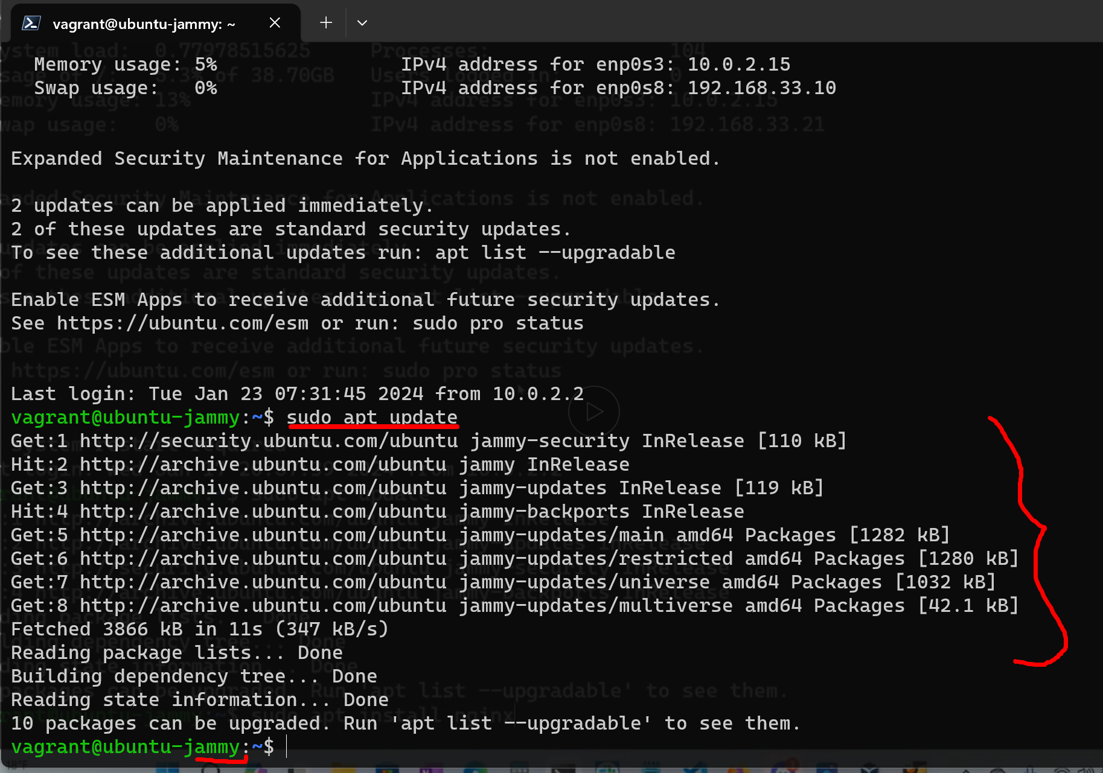

**INSTALL NGINX**:

Then I installed nginx with the command:

**sudo apt install nginx** click y in the middle prompt of the output

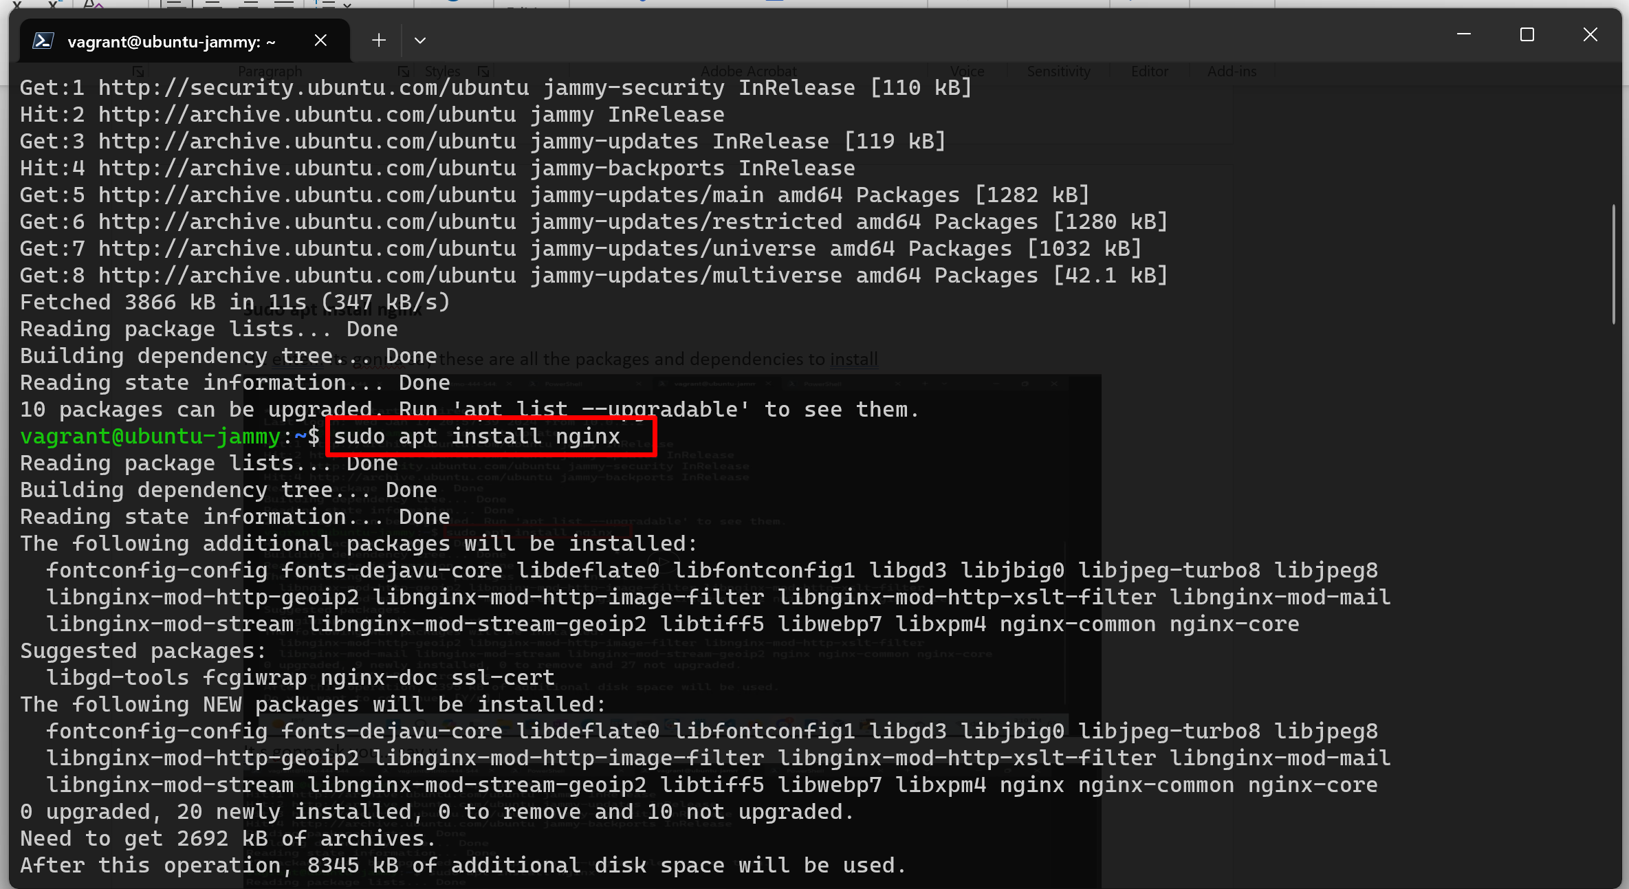

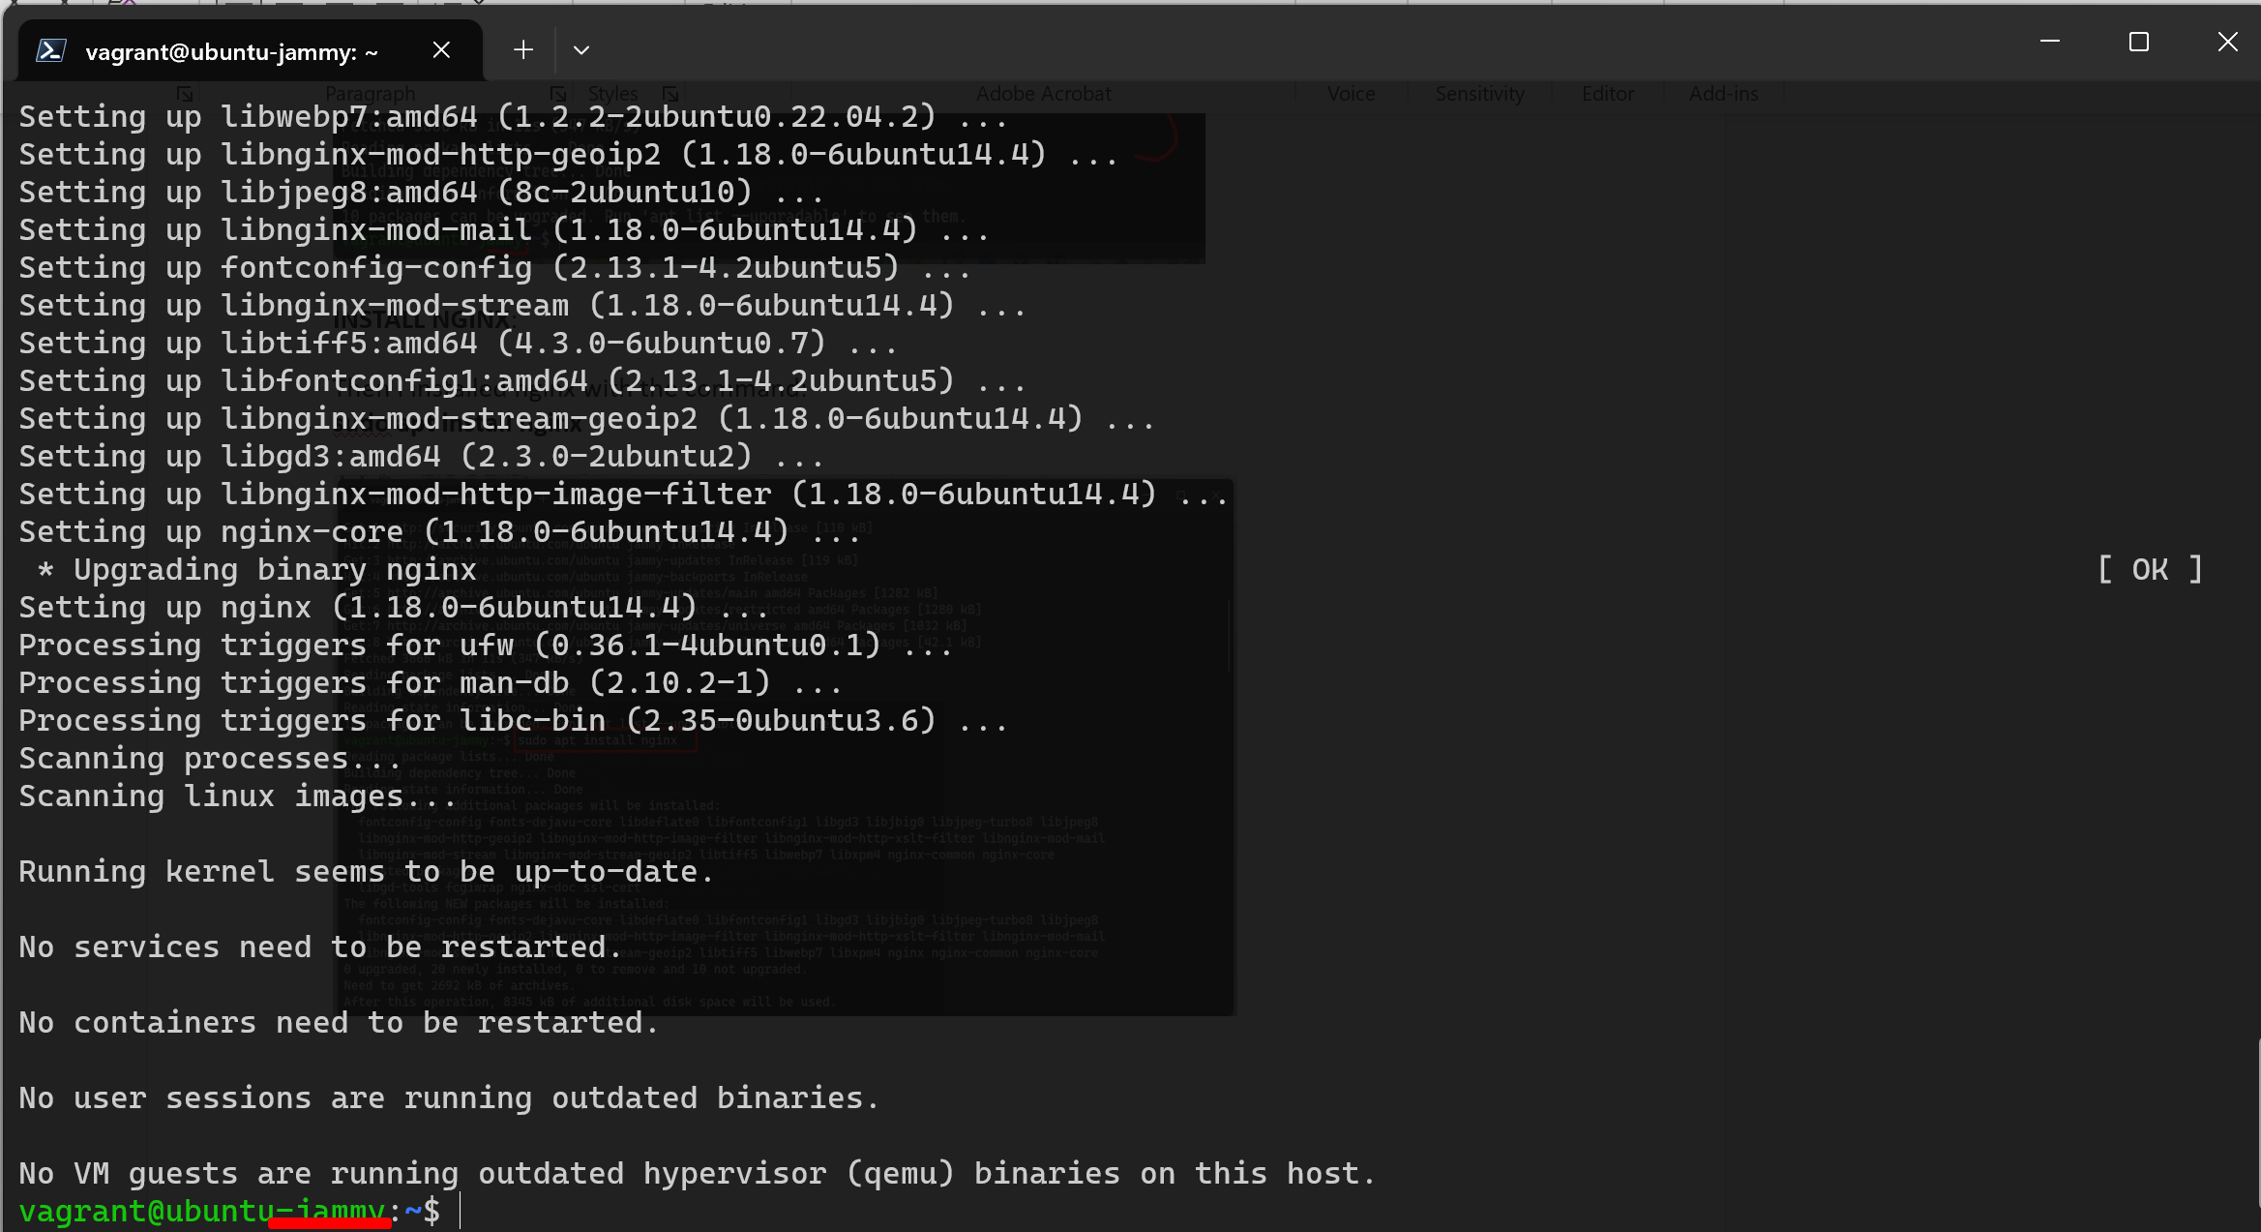

Now enable the nginx by default every time the system starts and reloads.. the command:

**sudo systemctl enable --now nginx**

and check the status with the command:

**sudo systemctl status nginx**

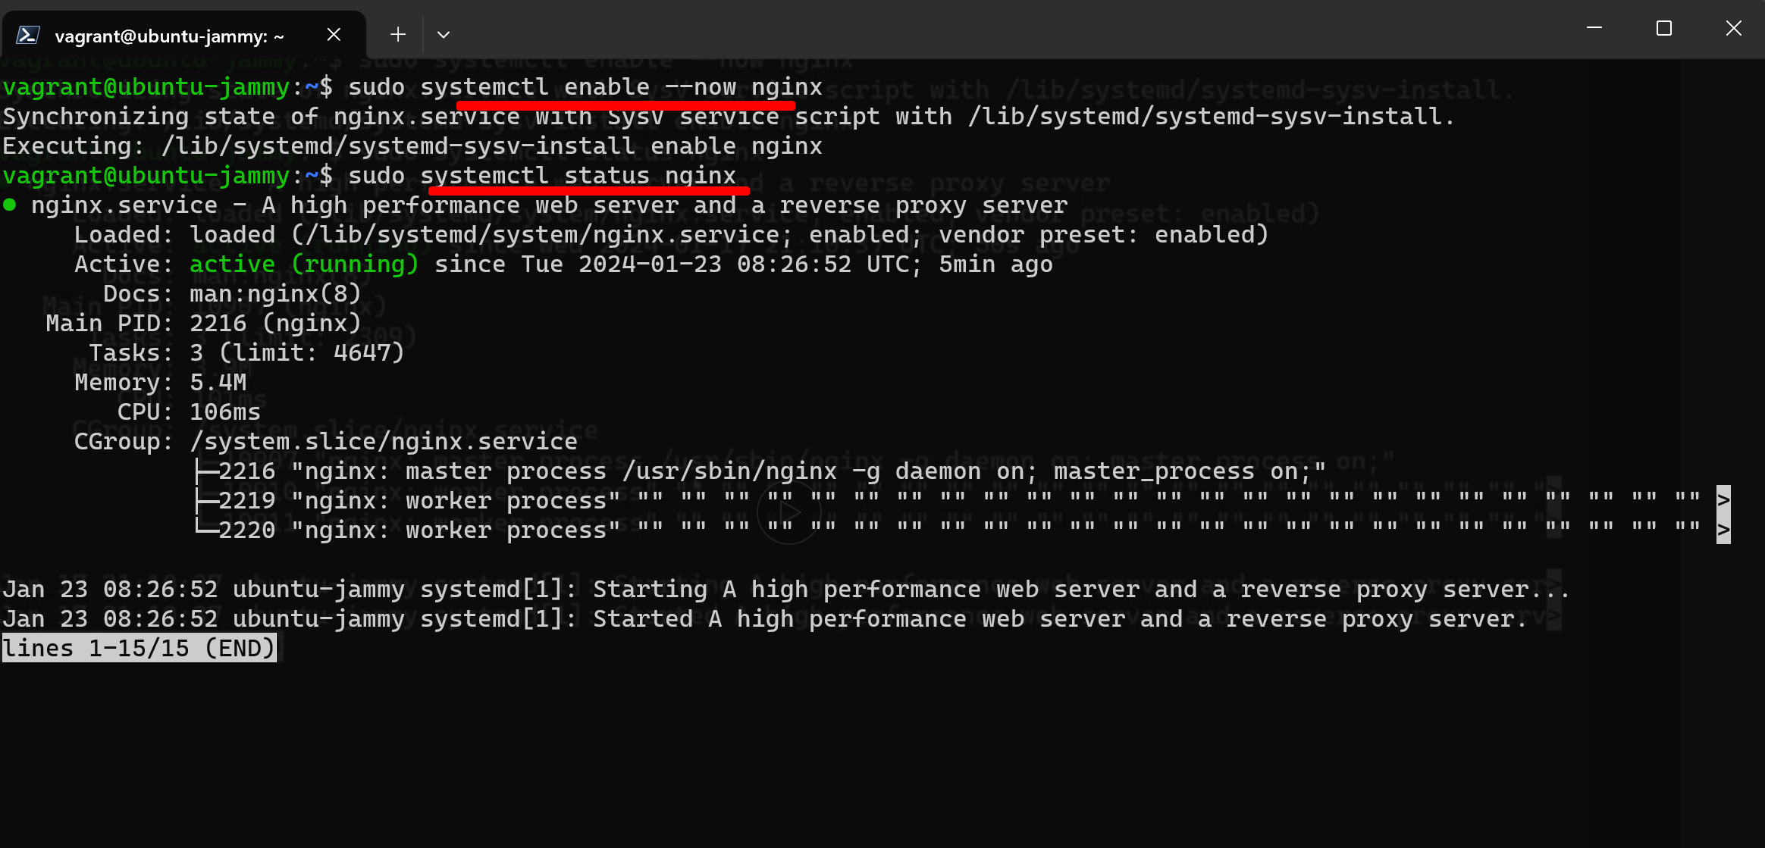

**Type q to quit here**

**Whats my address?**

**ip a sh**

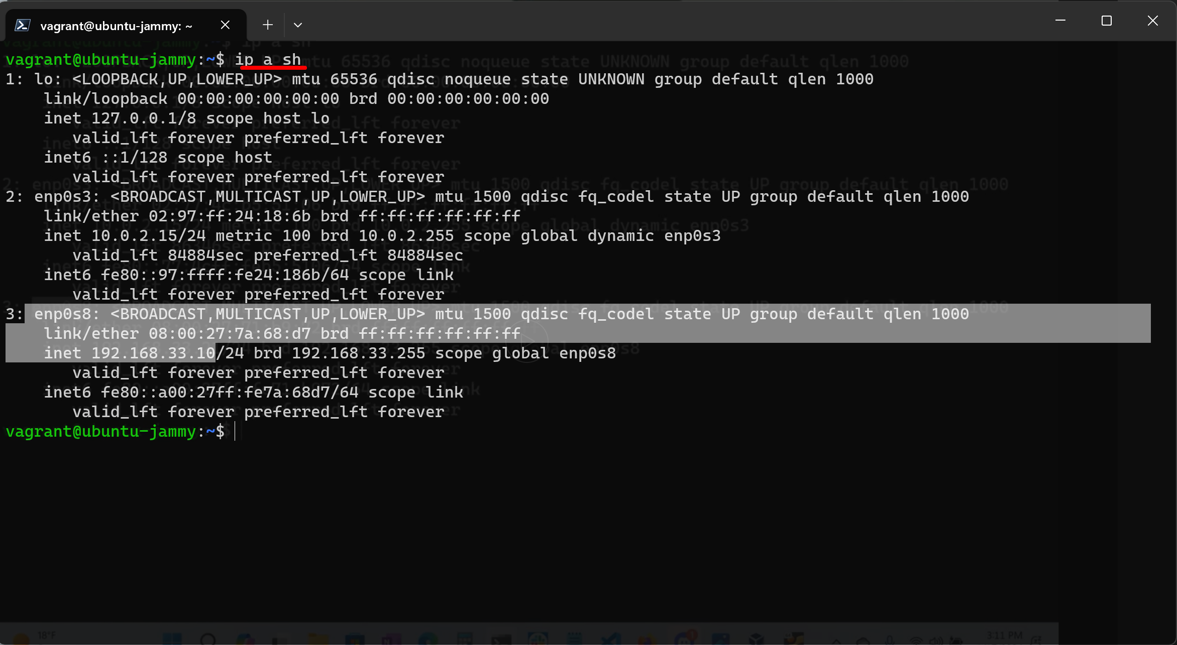

**Copy that ip address opened a browser ,pasted with http**

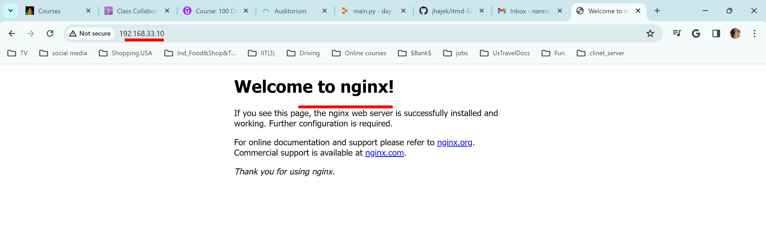

**Now install all the software’s** at the bottom of the instructions document:

We will do in jammy64 ubuntu only

**1, change the hostname** to include my course number & initials:

sudo hostnamectl set-hostname initials-and-class-number

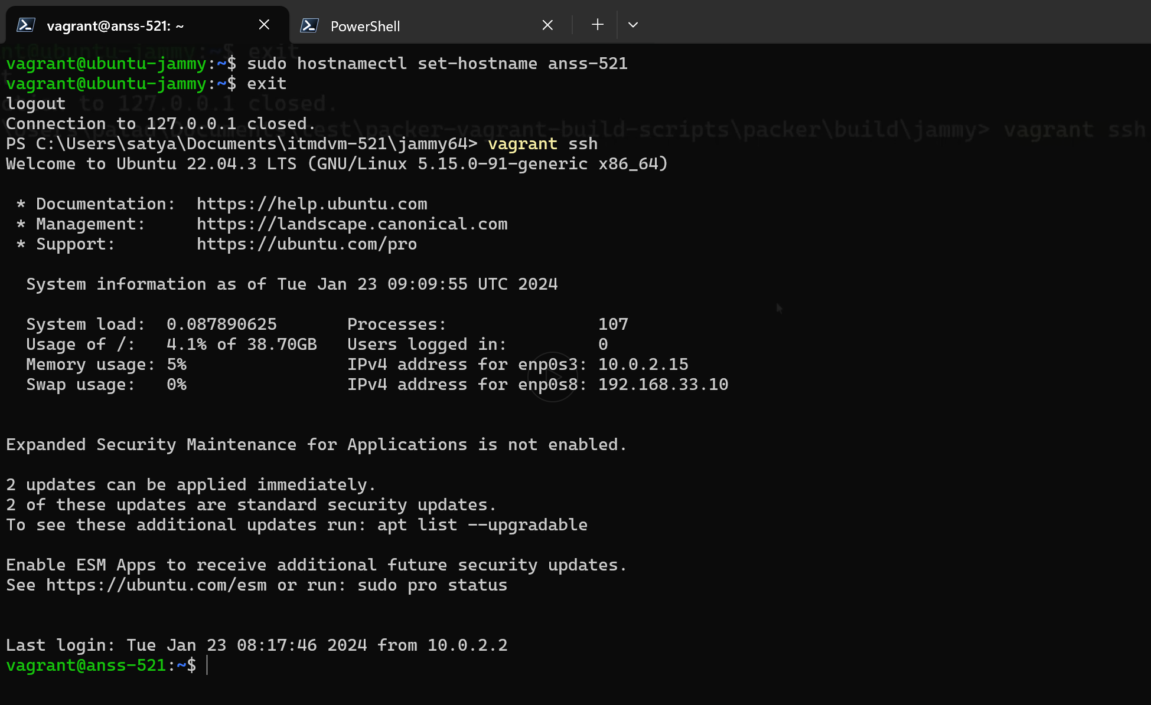

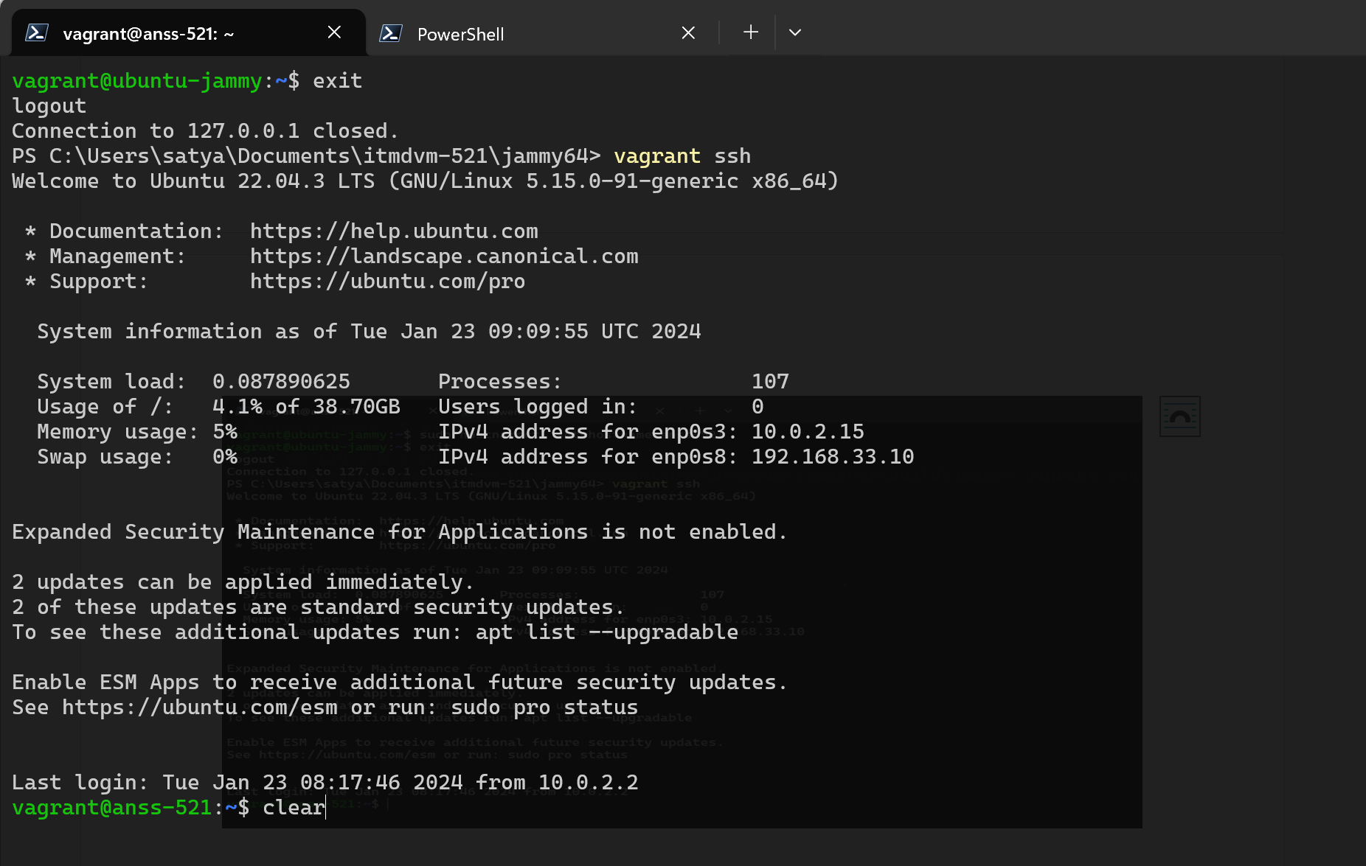

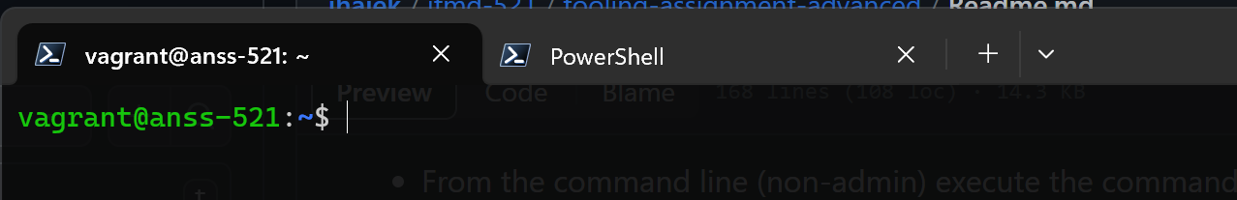

2.Add values to bash rc:

export JAVA_HOME=/usr

export SPARK_HOME=/home/vagrant/spark

export PYSPARK_PYTHON=python3

export PATH=$PATH:$SPARK_HOME/bin

the command is:

**vim ~/.bashrc**

we will come to the end of the file like this with down arrow in our keyboard(we can do vi here bcoz we are in vm)

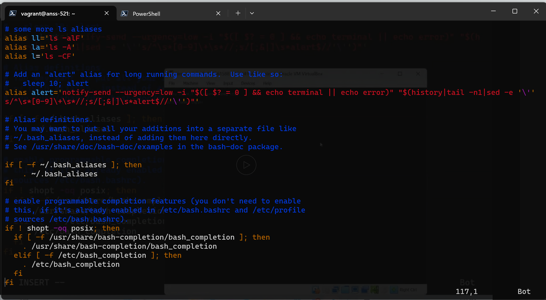

**Come to the moddle of fi (f and I middle) press esc o on our keyboard we will get new line**

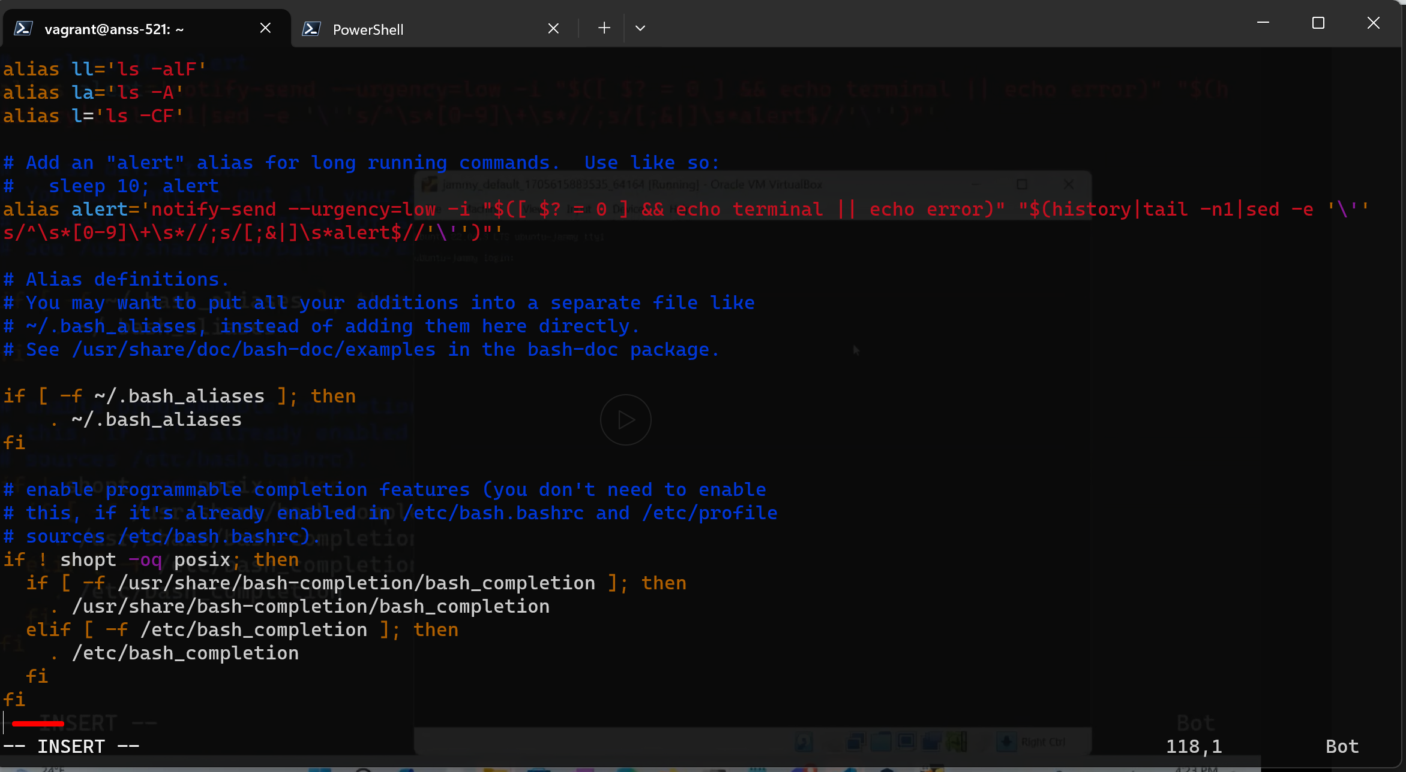

Type ZZ to quit with saving changes

**3. Install maria db:**

**sudo apt install mariadb-server**

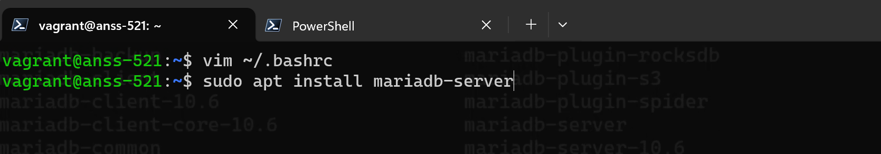

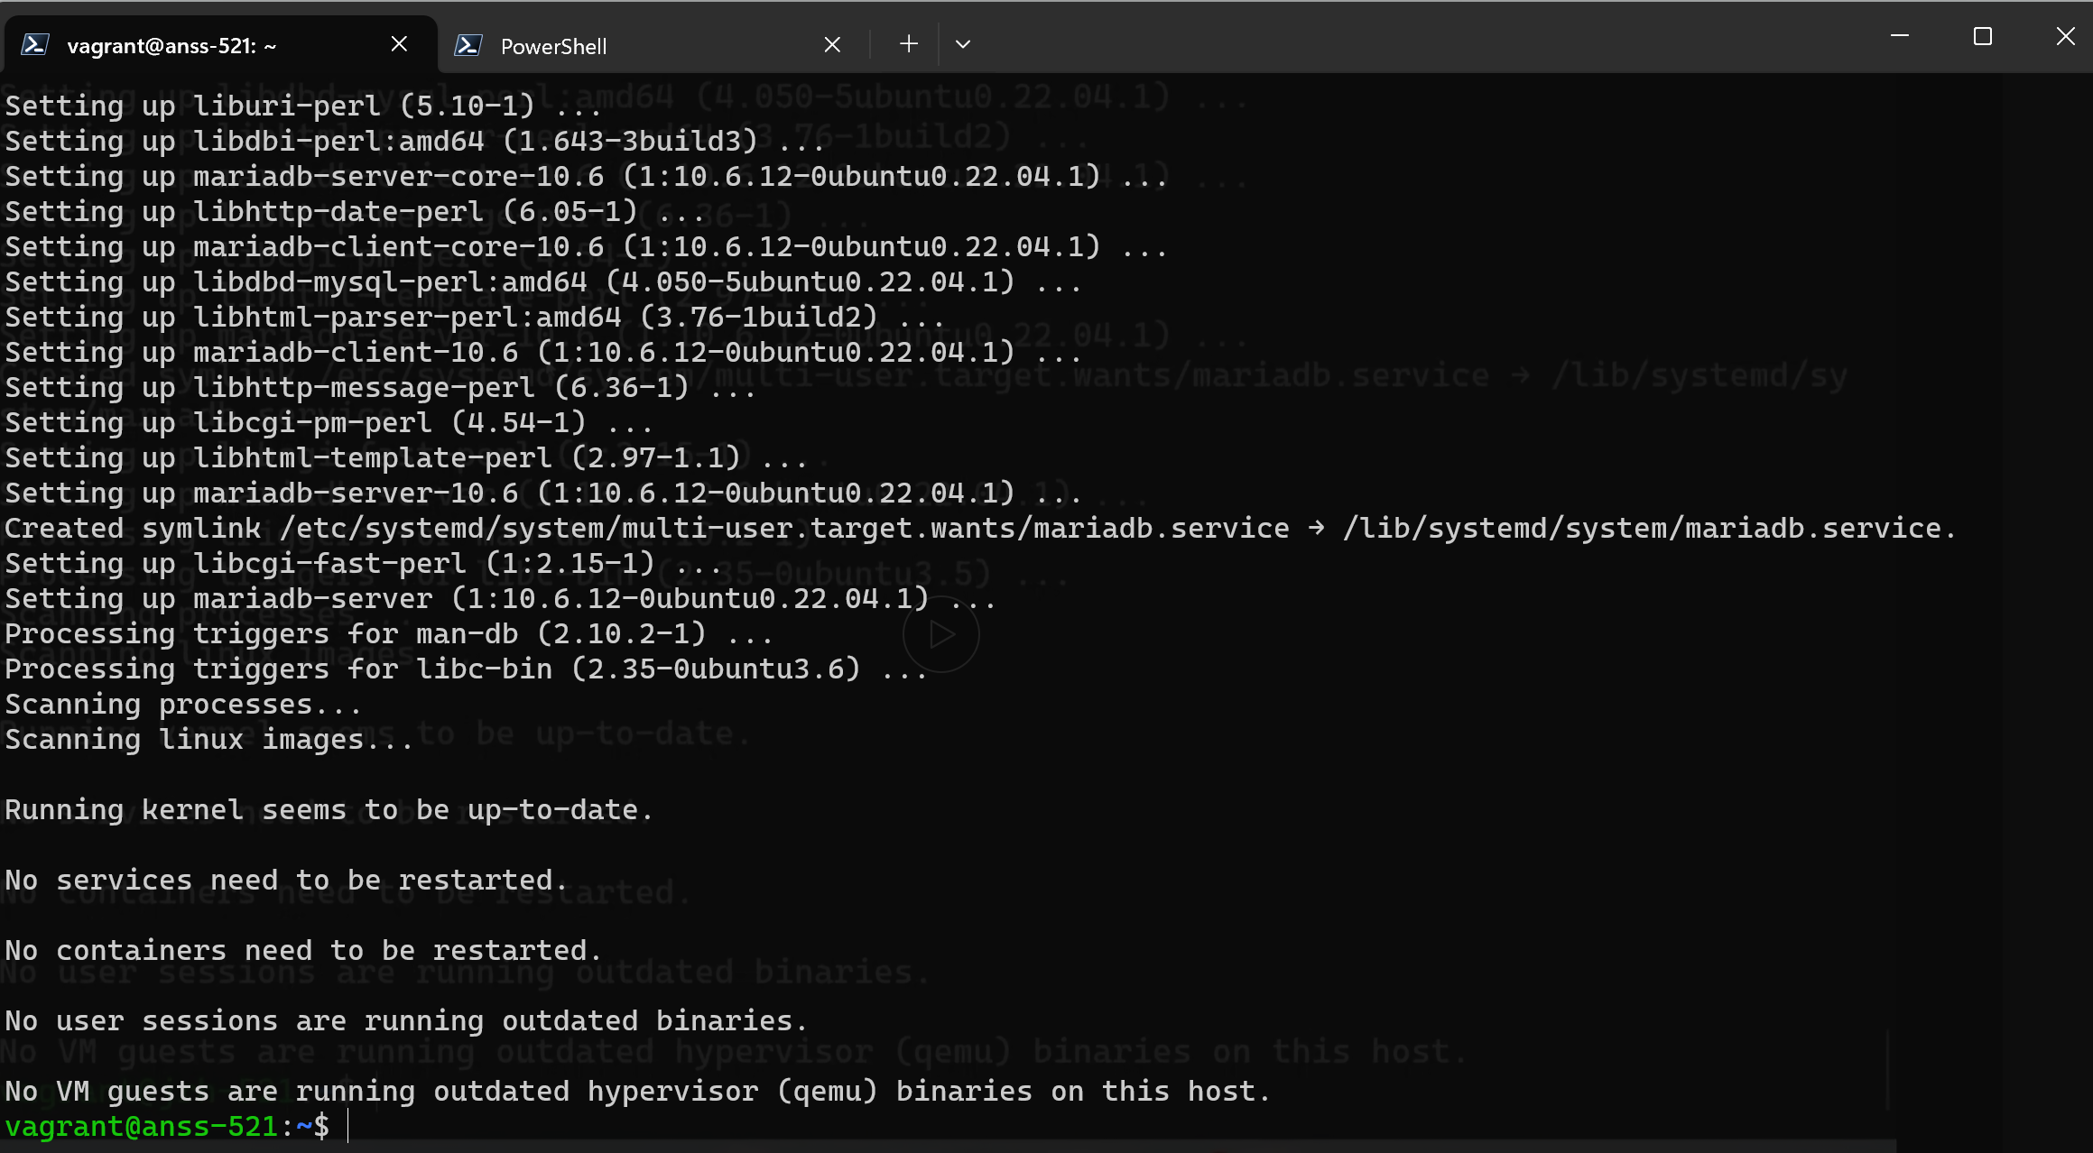

**Install Java 11 OpenJDK:**

**sudo apt install openjdk-11-jdk**

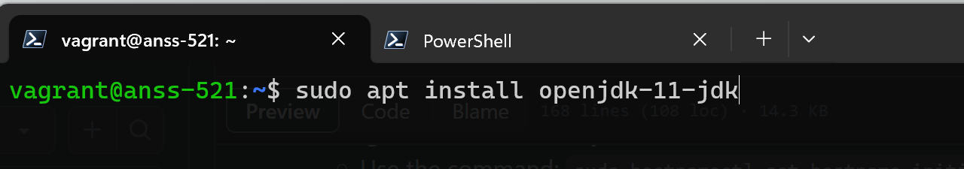

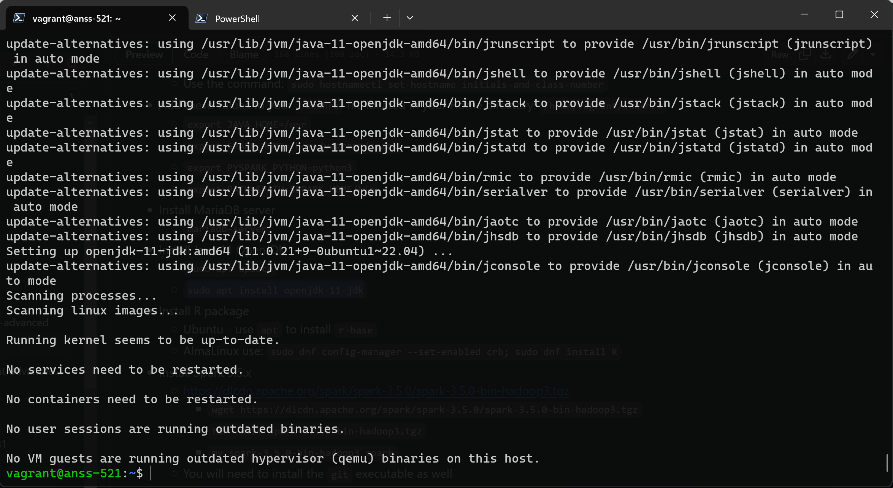

**Install r-base**

**sudo apt install r-base**

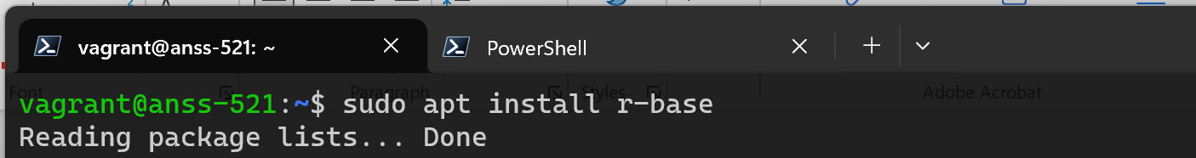

r-base took too long to install

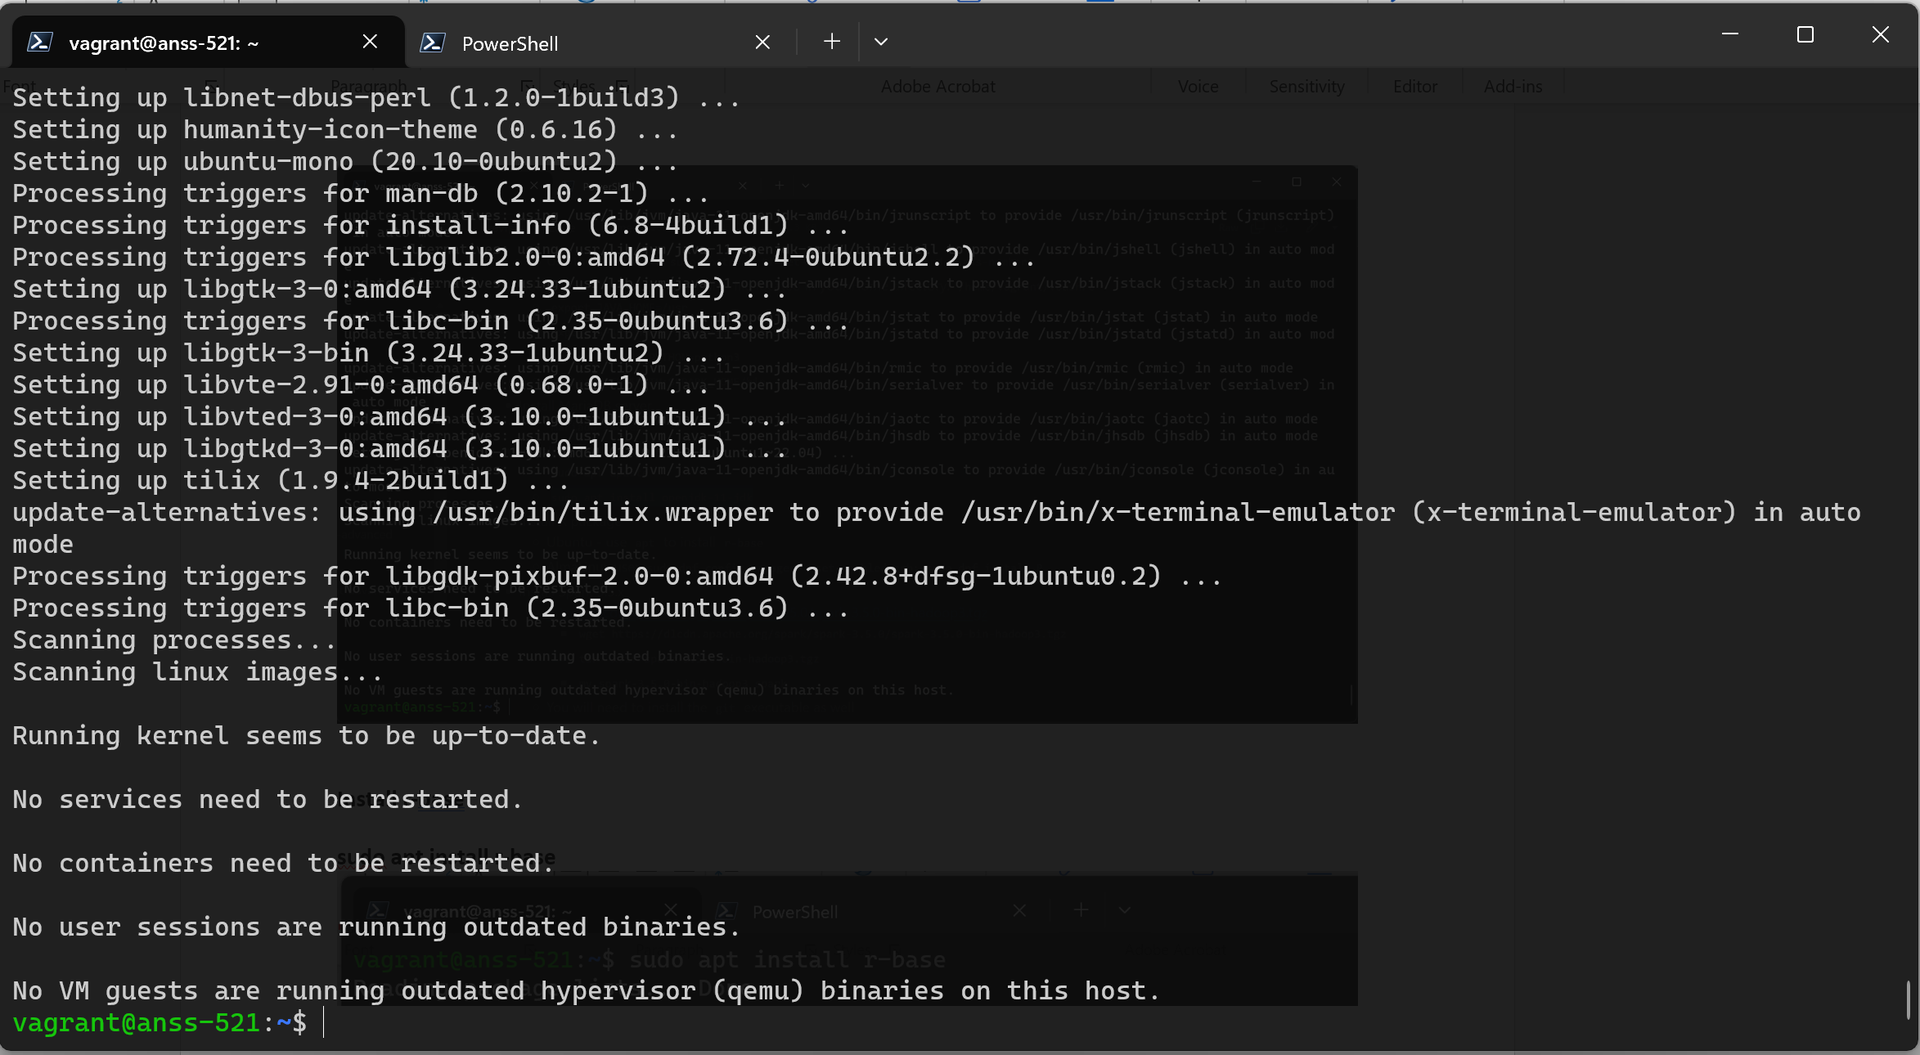

**Install apche spark:**

**wget https://dlcdn.apache.org/spark/spark-3.5.0/spark-3.5.0-bin-hadoop3.tgz**

**tar -xvzf spark-3.5.0-bin-hadoop3.tgz**

**mv spark-3.5.0-bin-hadoop3 spark**

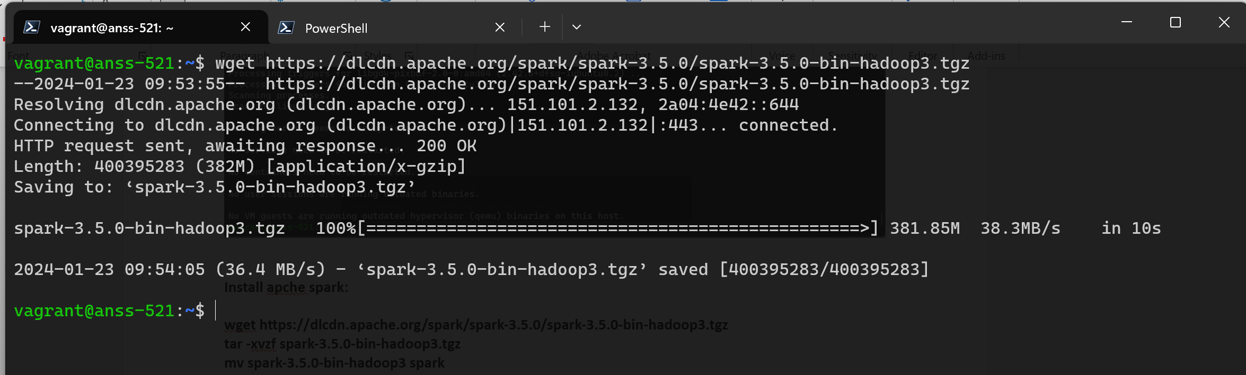

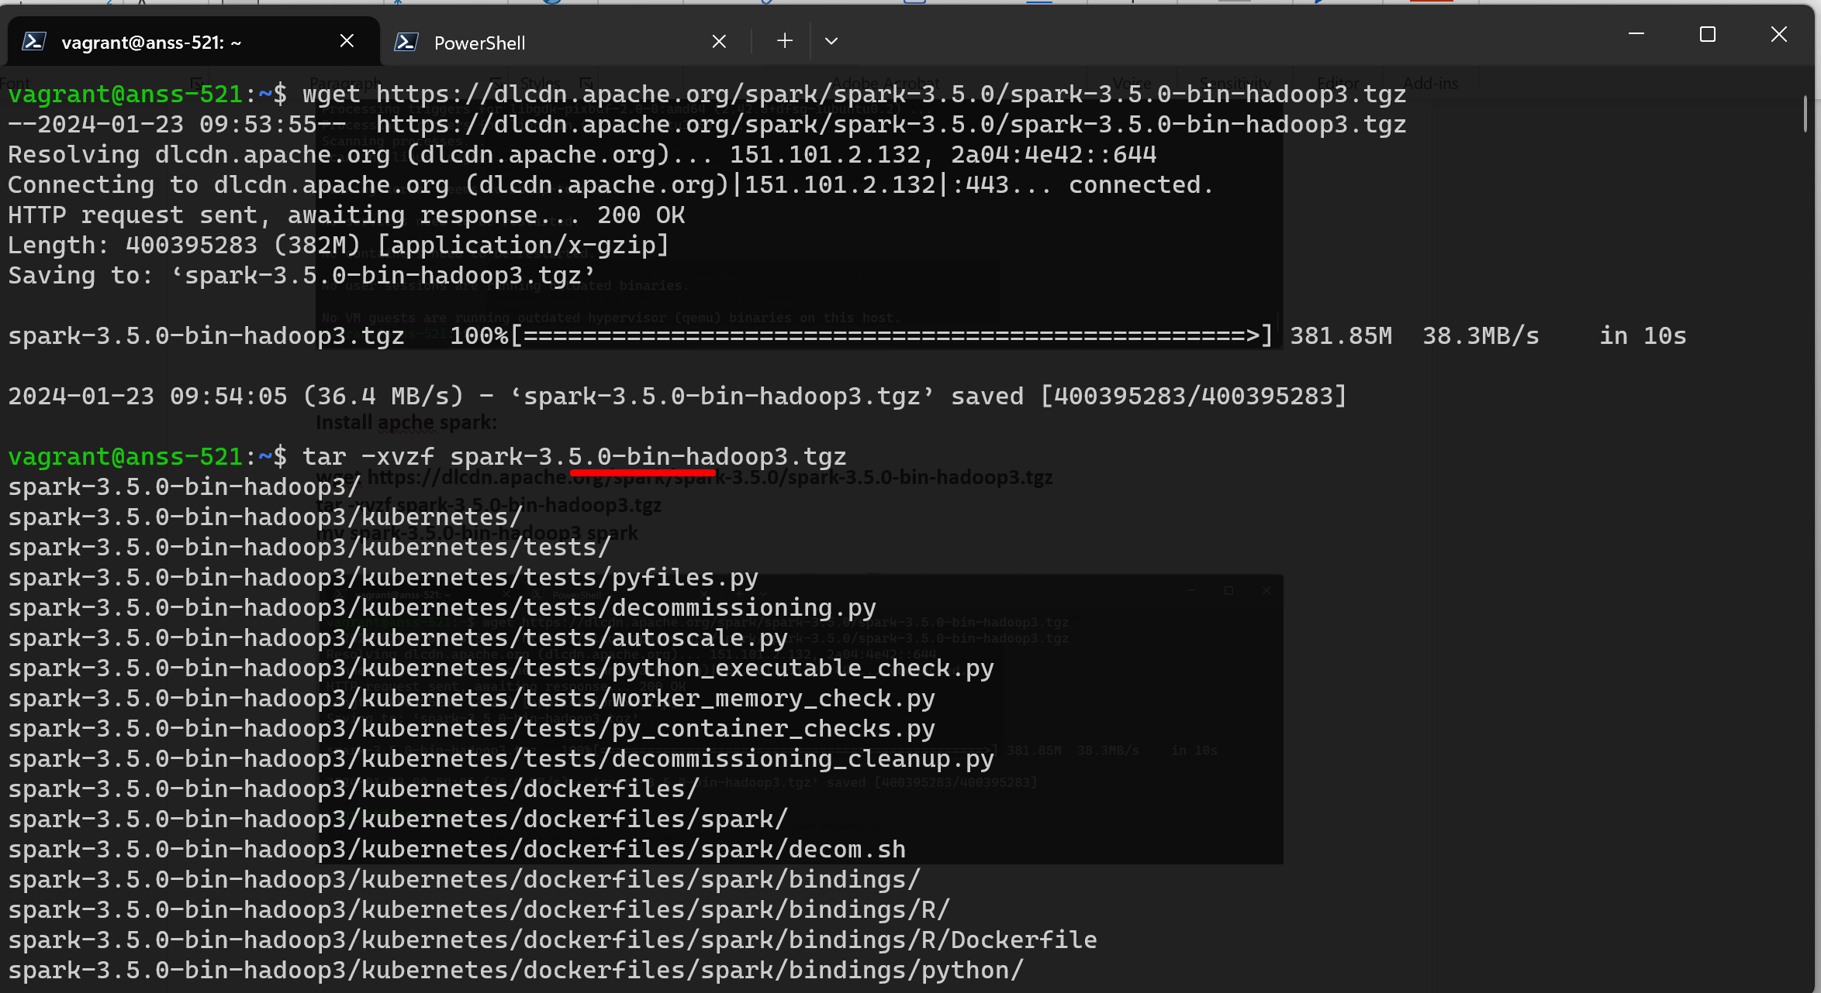

**Very long output….here is the end:**

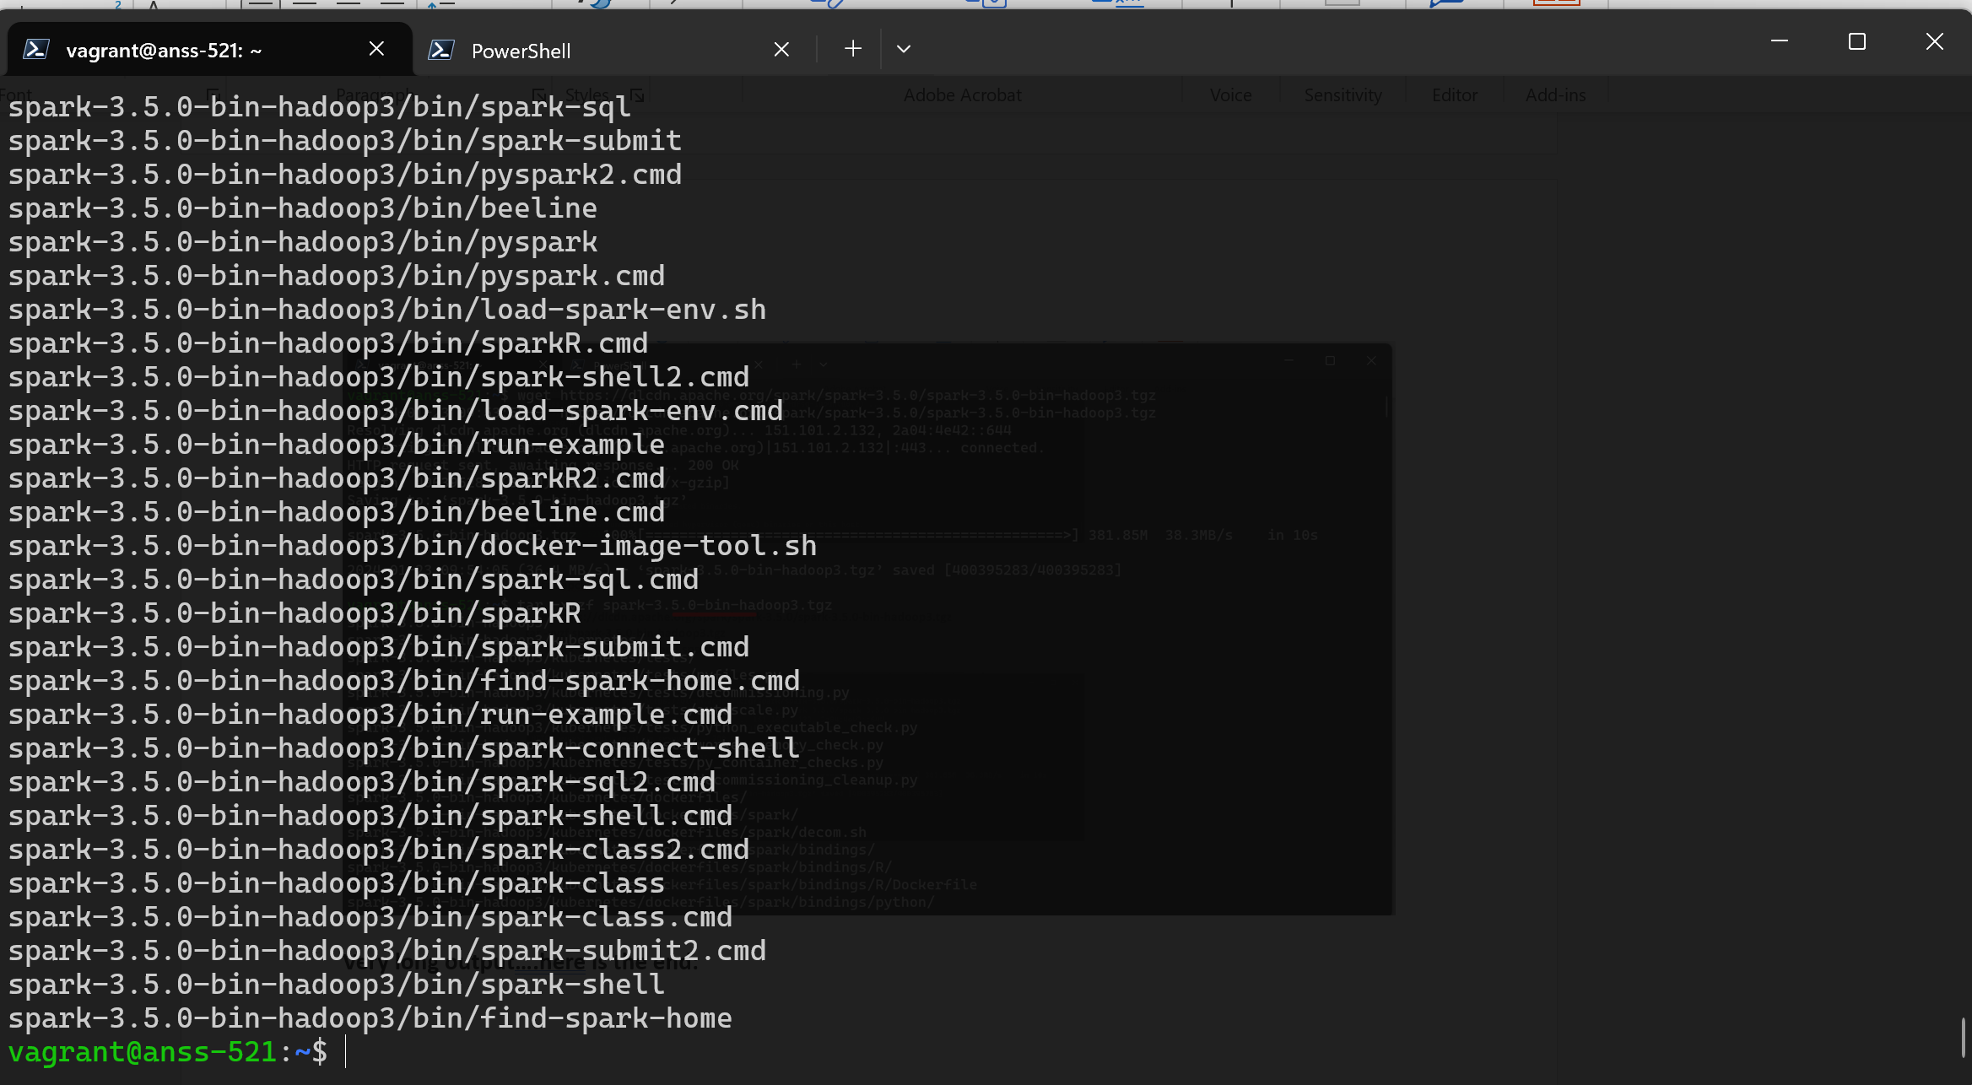

**Install git:**

**sudo apt install git**

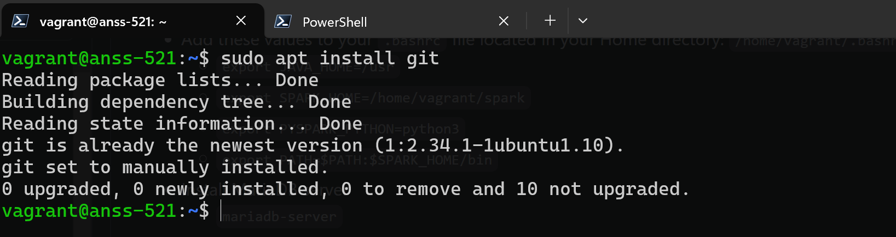

**SCREENSHOTS**

**Pyspark :**

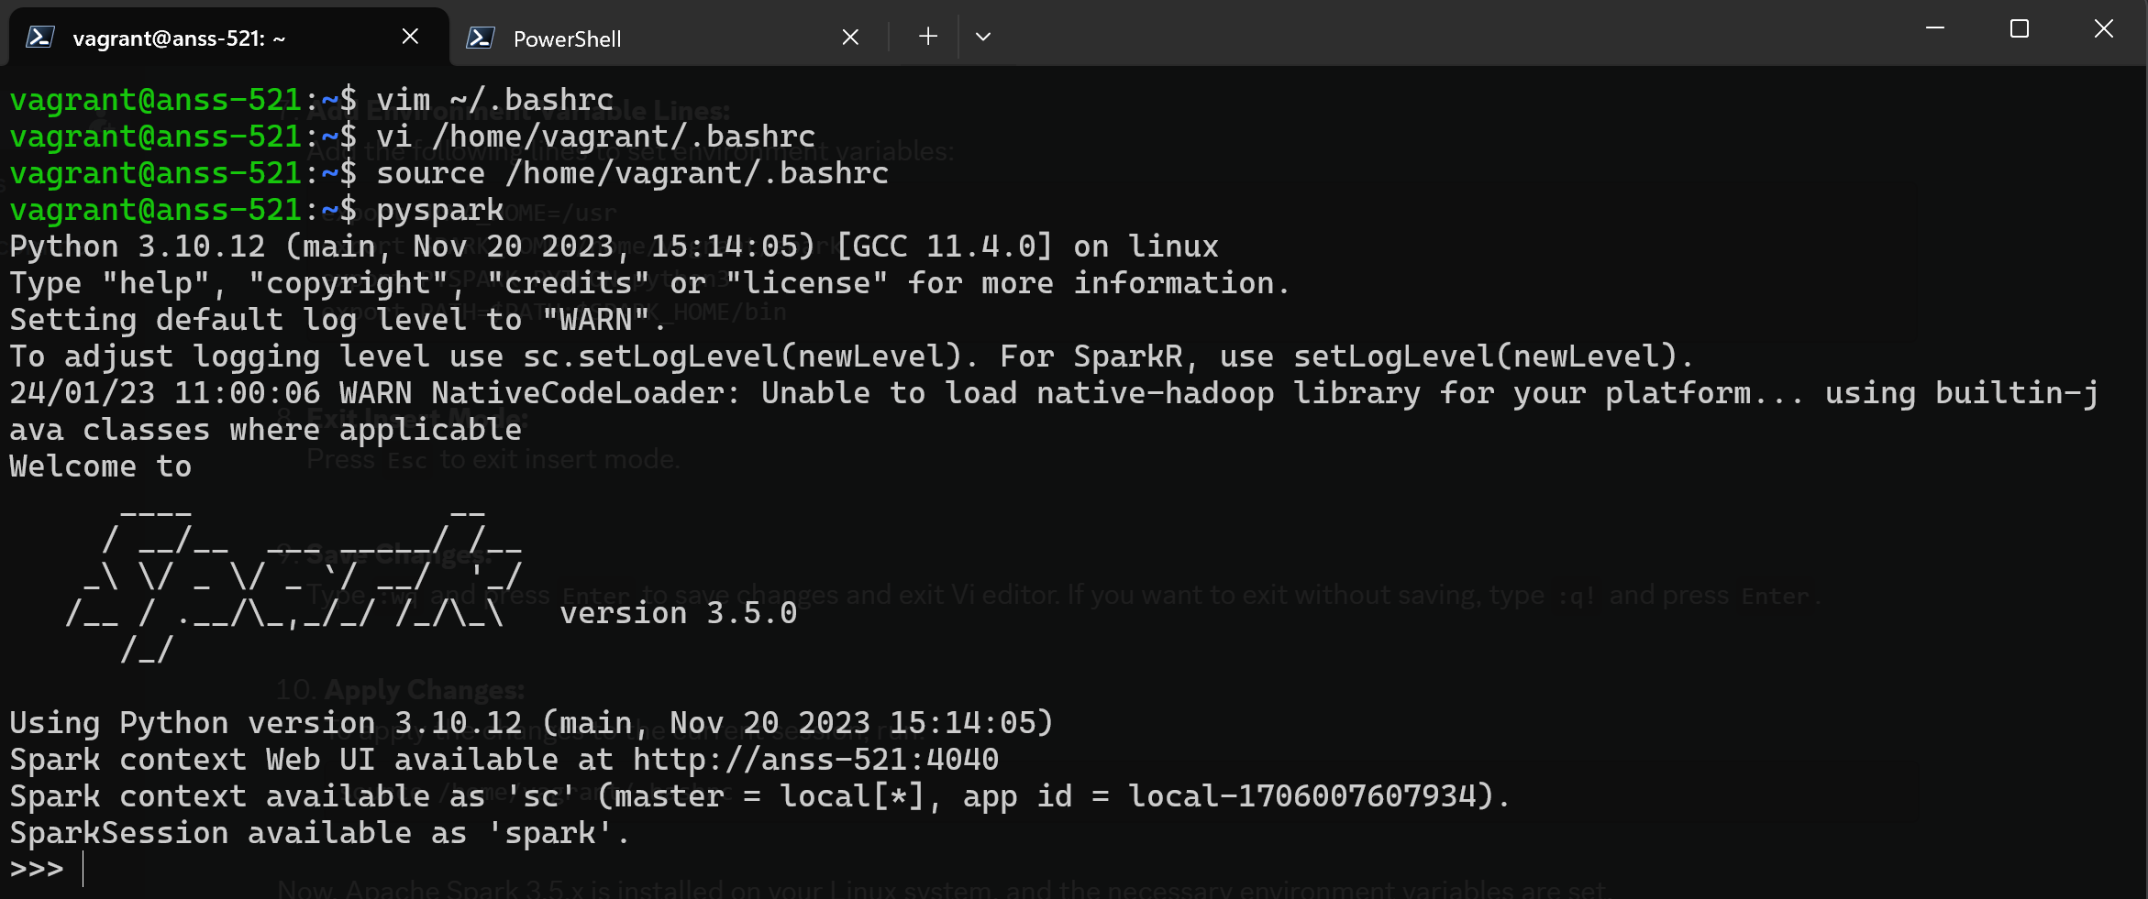

**Type exit()**

**Spark-shell:**

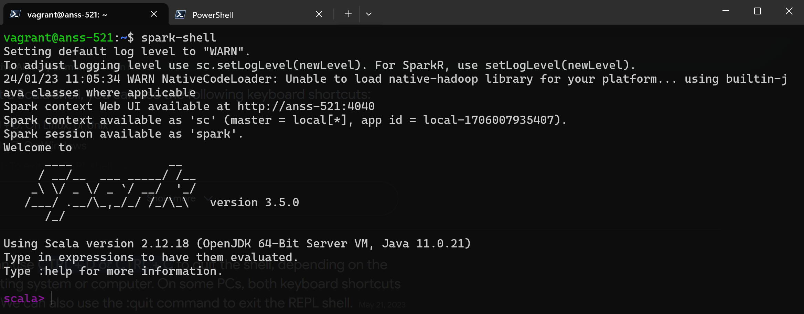

**Press cntrl D to quit**

**R -v:**

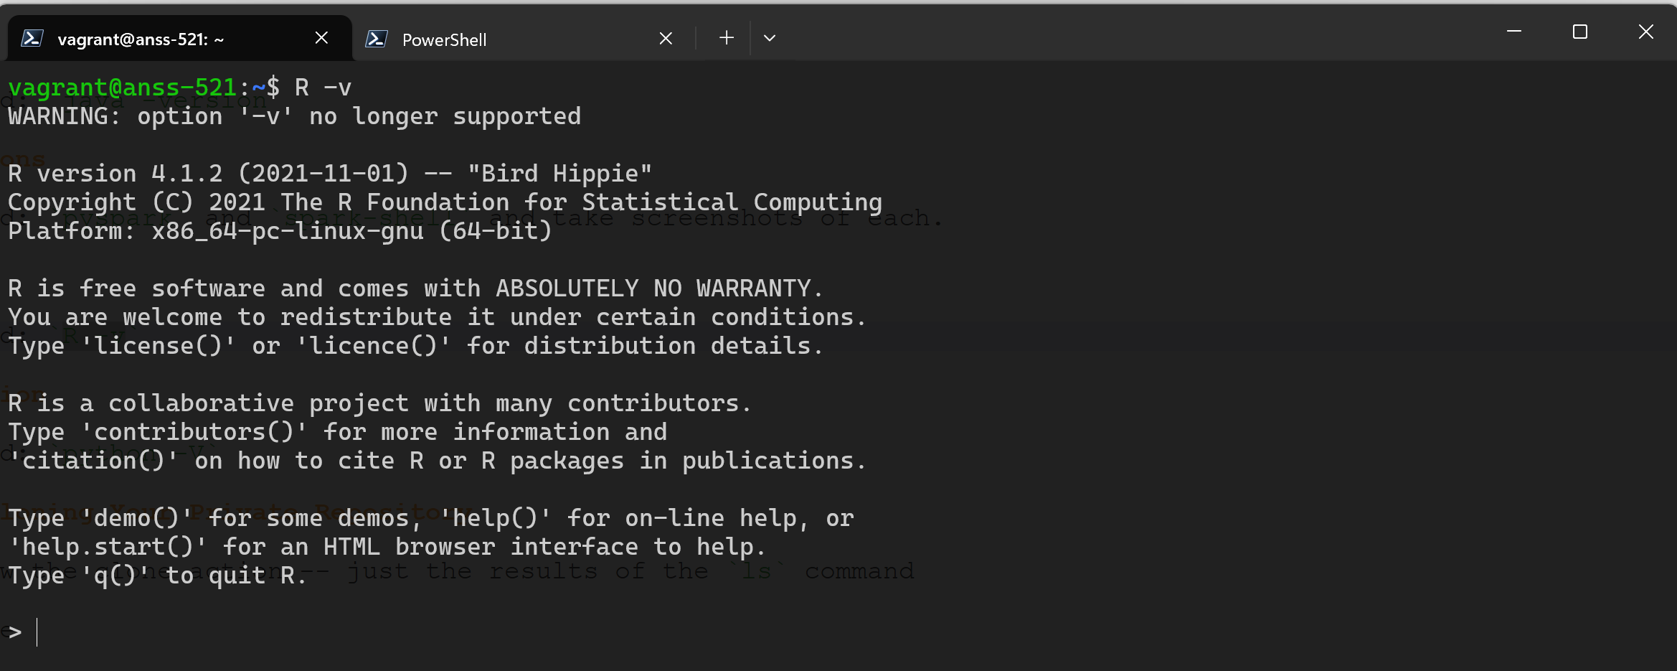

**Python -V**

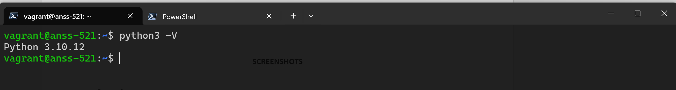

**Mysql -V**

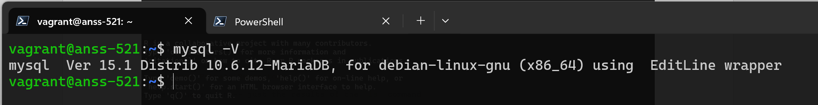

**Java version**

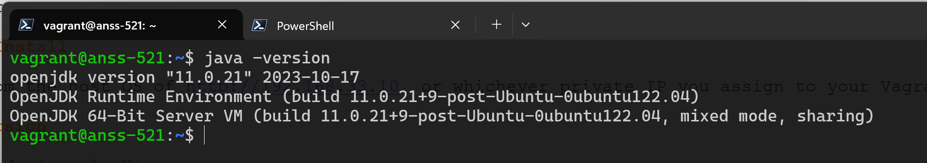

**Hostname change:**



**Webserver: nginx**



Vagrnt box list from documents directory of when you did exit from anss(previously jammy vm)

You will be in in jammy

Do

**vagrant box list:**

**Result of Git clone and ls:**

**git clone** [**https://github.com/illinoistech-itm/nannadevara**](https://github.com/illinoistech-itm/nannadevara)

for cloning in git, we need to do git tutorial from config username and email step to clone …just like how we did in our local system, buy now we need to do it in vagrant-ubuntu(anss-521)

**here:**

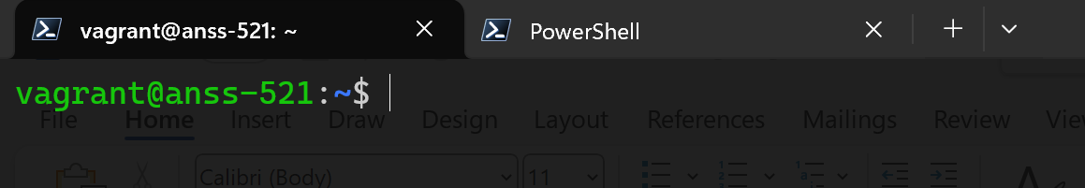

**Config username and email:**

**git config --global user.name "Naga Satya Shilpa"**

**git config --global user.email “nannadevara@hawk.iit.edu”**

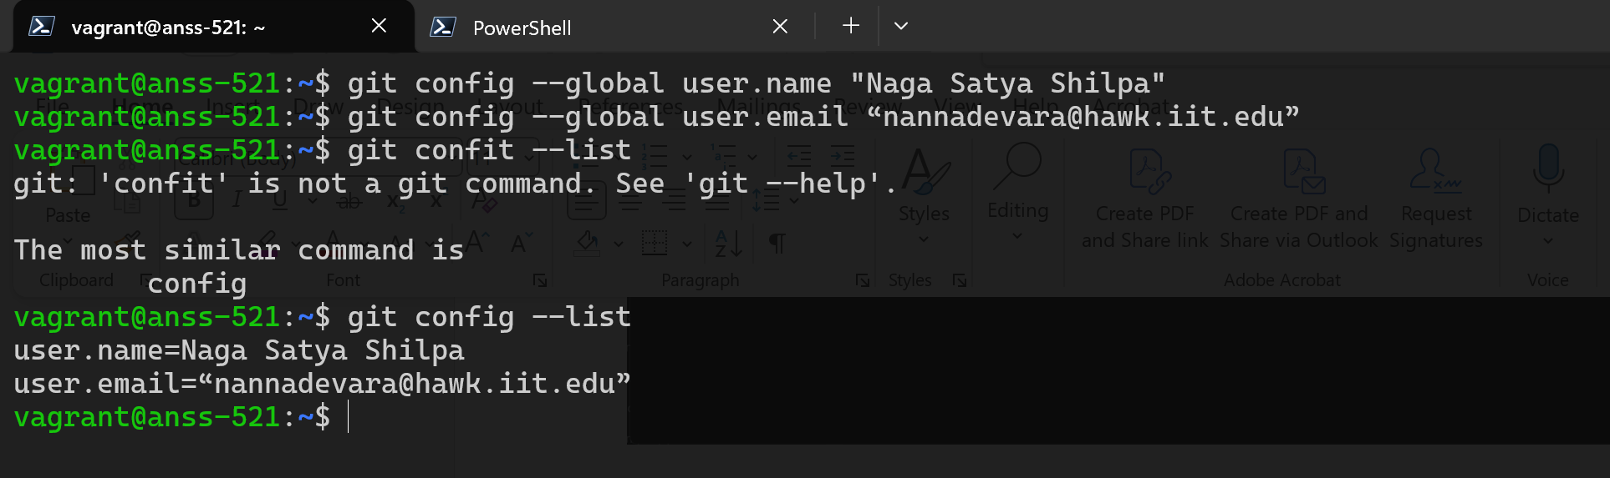

**create key pair for authentication:**

**ssh-keygen -t ed25519**

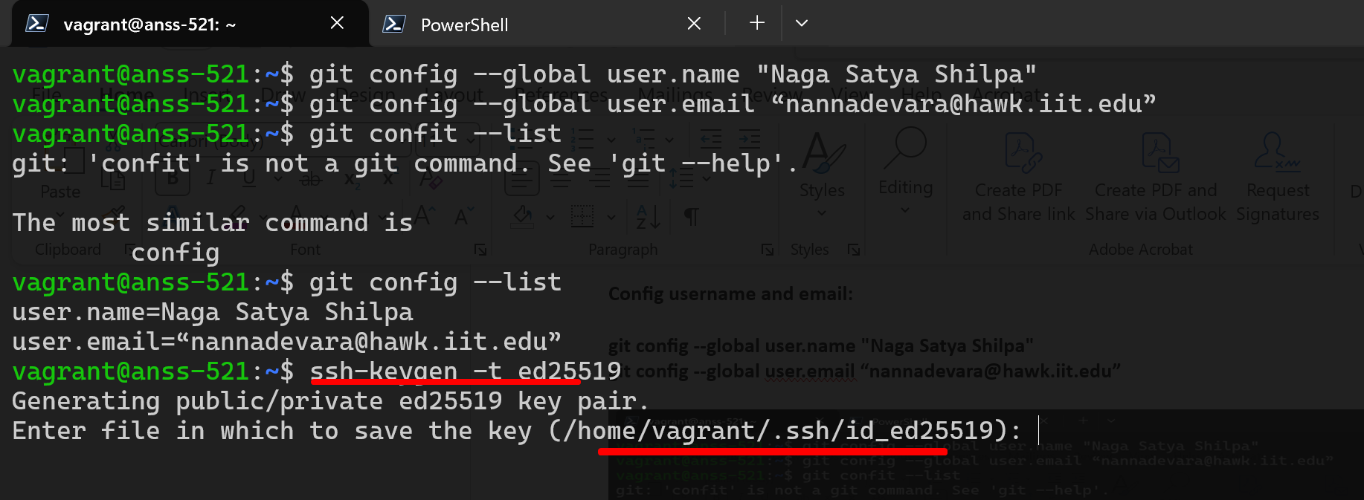

The file is **/home/vagrant/.ssh/id_ed25519**

Then match with the path and enter your wish file name as follows: copy the above path first and then extend the path with whatever file name suitable for this subject: (path_github_itmdvm521_key)

So enter this here:

**/home/vagrant/.ssh/id_ed25519_github_itmdvm521_key**

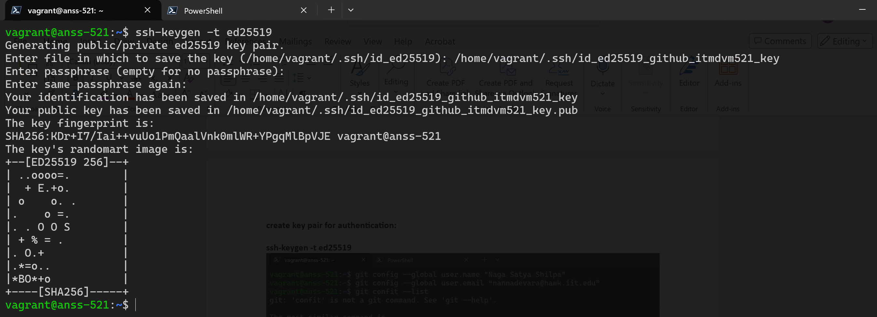

**Your identification has been saved in /home/vagrant/.ssh/id_ed25519_github_itmdvm521_key**

**(private key)**

**Your public key has been saved in /home/vagrant/.ssh/id_ed25519_github_itmdvm521_key.pub**

**(public key)**

Now display the public key:

**cat** **/home/vagrant/.ssh/id_ed25519_github_itmdvm521_key.pub**

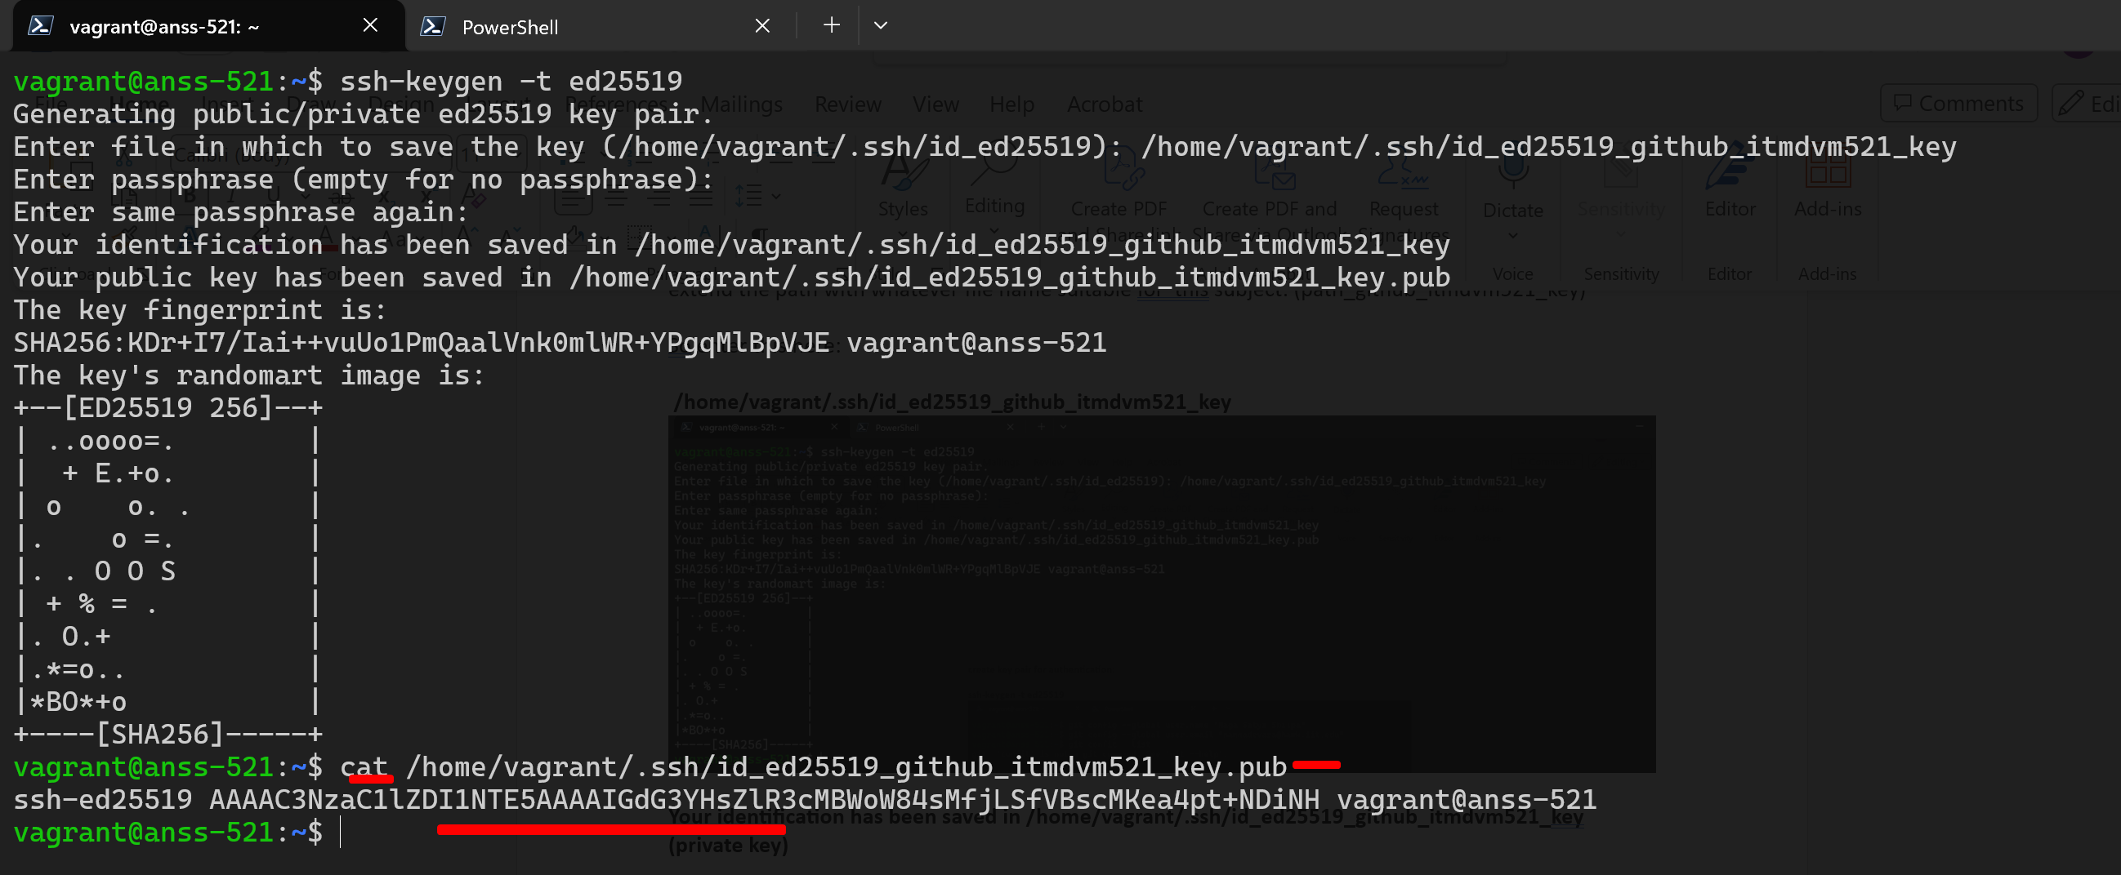

**The public key is:**

**ssh-ed25519 AAAAC3NzaC1lZDI1NTE5AAAAIGdG3YHsZlR3cMBWoW84sMfjLSfVBscMKea4pt+NDiNH vagrant@anss-521**

and then added this public key in github -setting – ssh gpg keys – add ssh key – paste this key – add appropriate title and save. (title could be itmdvm)

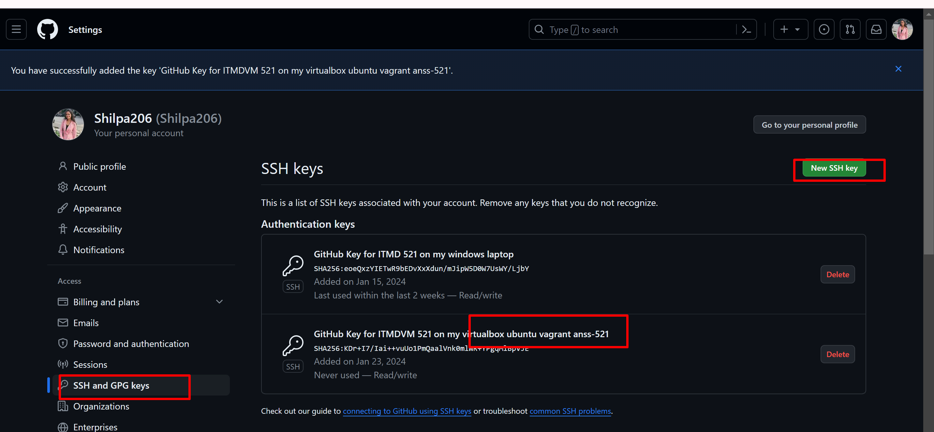

**lets create config file**: Every user have .ssh directory under home directory

What is home directory? When you open ‘terminal’ – powershell 7 – whatever shows initially, it is our home directory. For instance mine is : vagrant@anss-521

To check whether .ssh directory is there by default or not, type **ls -a or ls -al** in home directory (vagrant@anss-521) (in bash shell ubuntu) and check like this

(note that .ssh the dot is because it is hidden file,in windows hidden files will be shown with ls command but in birtualbox ubuntu hidden files willnot be shown with ls command. that’s why ls -al)

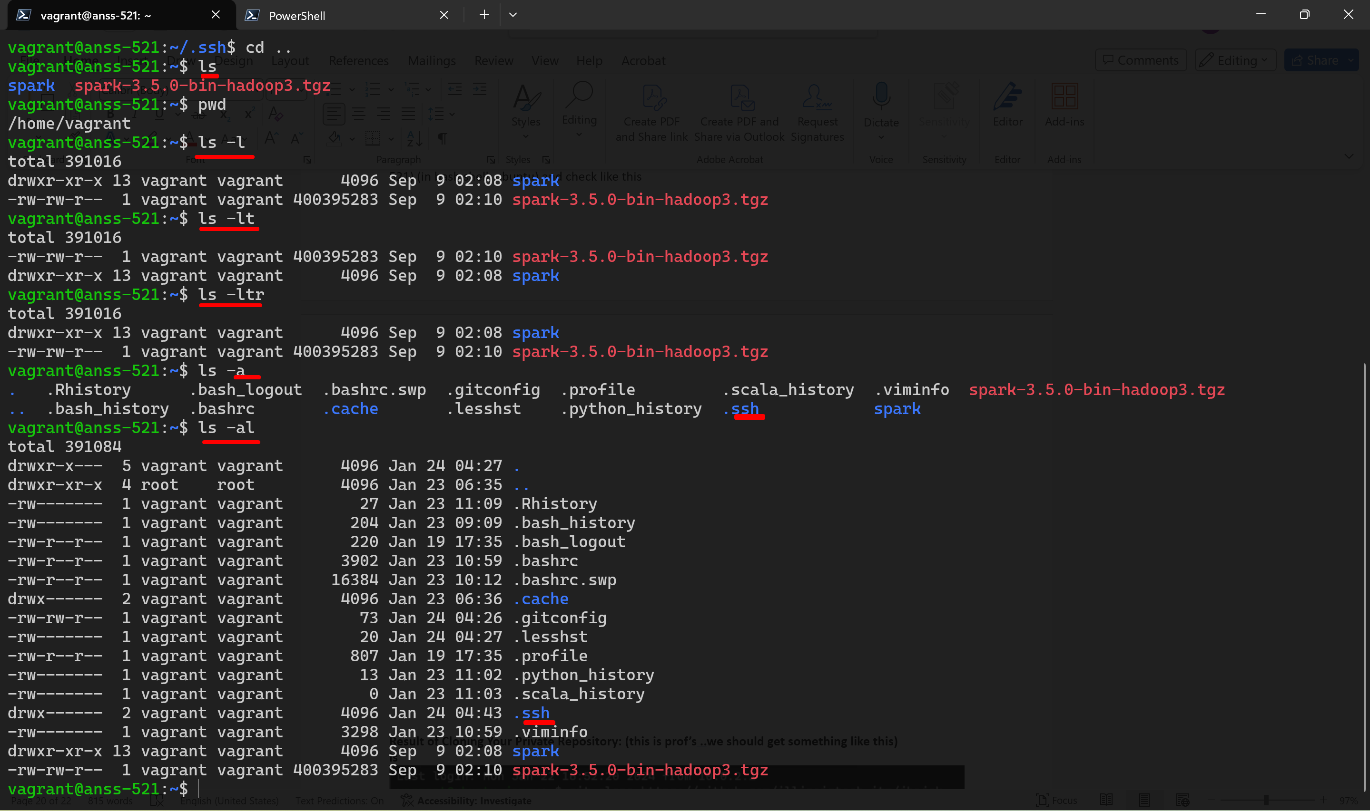

**Note the above are diff commands to show the list in that directory in different ways.**

This ssh directory only shows up only if you did that ssh keygen command earlier. Or else it wont show up. That command forces you to create this ssh directory.

Lets go to ssh directoty by using cd command:

**cd .ssh**

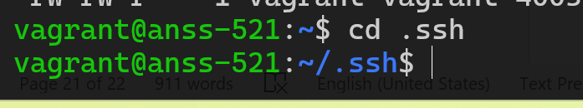

Now we are in ss directory

Type ls

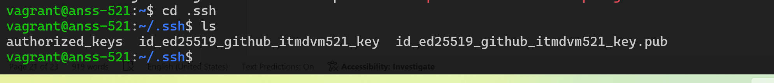

Professor will have a lot of things , but for us only these 2 will be there.

These are our pub and private keys

Now **create a file called config** : (prof already have config file so he just did cat config, tio show us how it looks like. So when he did, he got a screen saying that when we conncect to host ~ github.com use these values. user is the github ID not the repository(whatever ID we submitted to professor), Identity file is the path to the private key (look at th ssh keygen screenshot to get this path) , so that when we connect to github , it will present the key to authenticate, and authenticate us without we typing any passwords ) 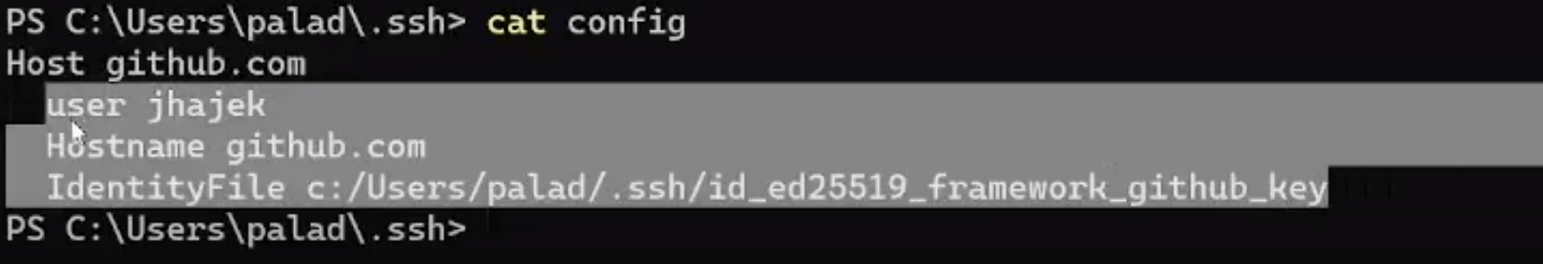

But for us first we need to create config file:

As we are in virtualbox, we don’t have code(vscode texteditor top create and open the config file)

So we need to vi

**vi config**

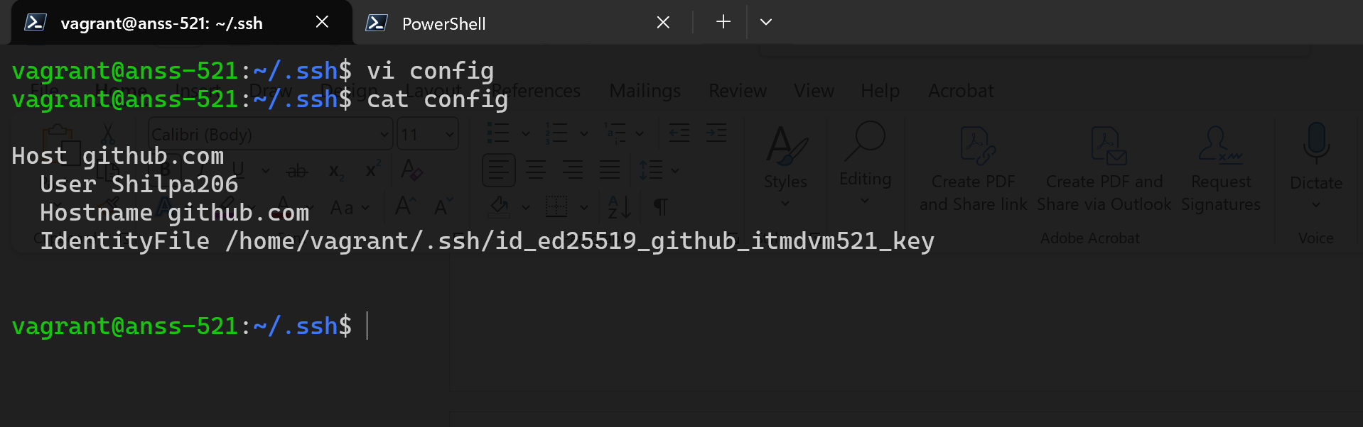

Host github.com

User Shilpa206

Hostname github.com

IdentityFile C:/Users/satya/.ssh/id_ed25519_github_itmd521_key

Now lets clone it

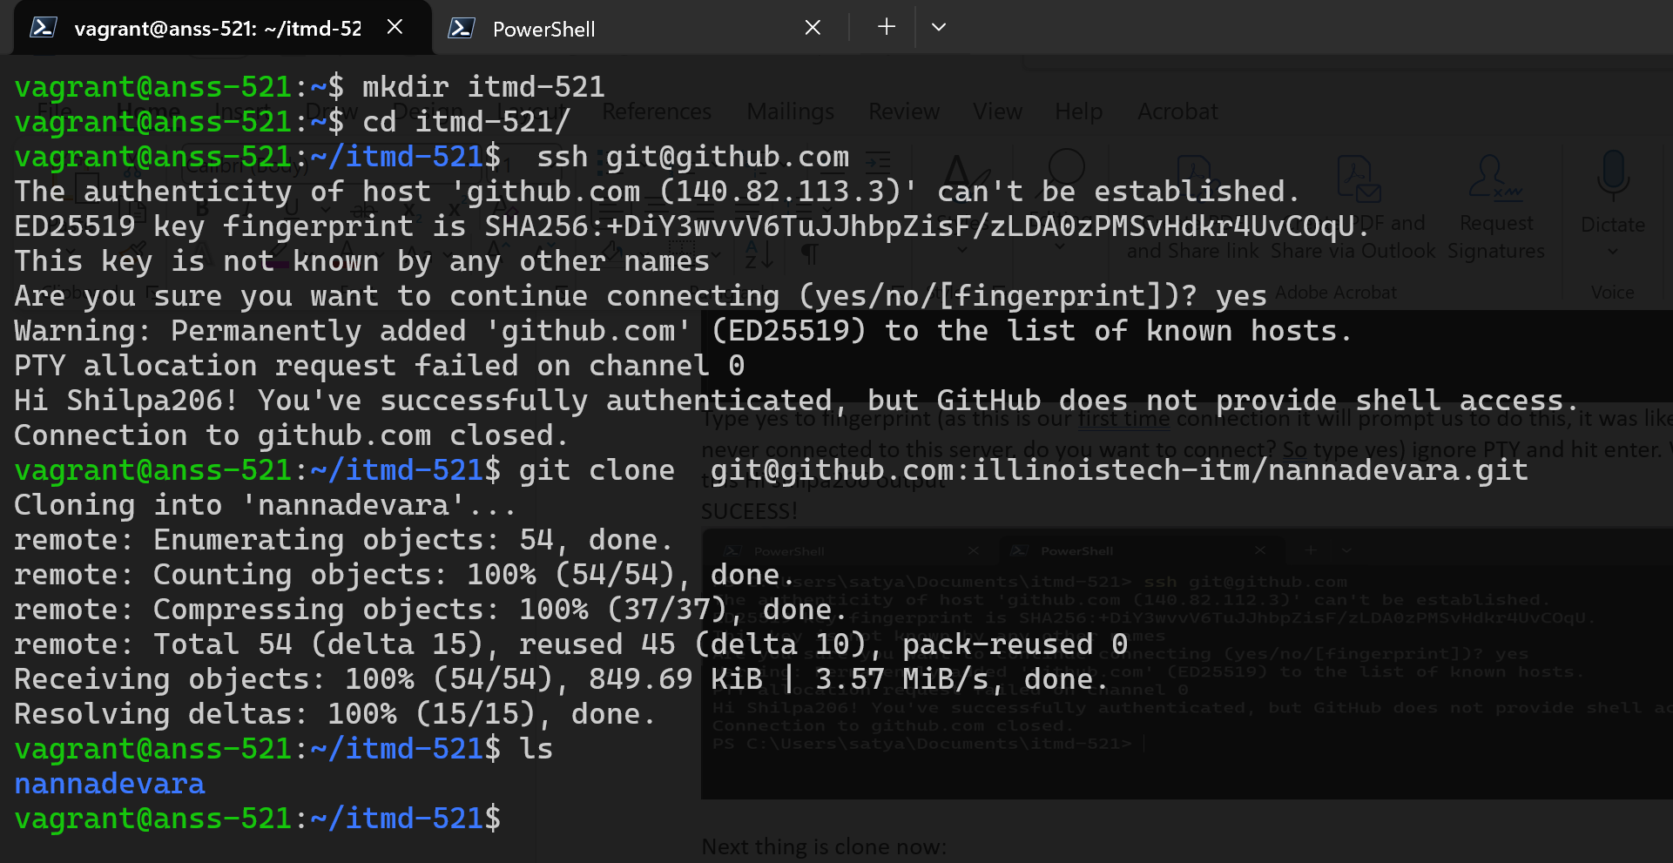

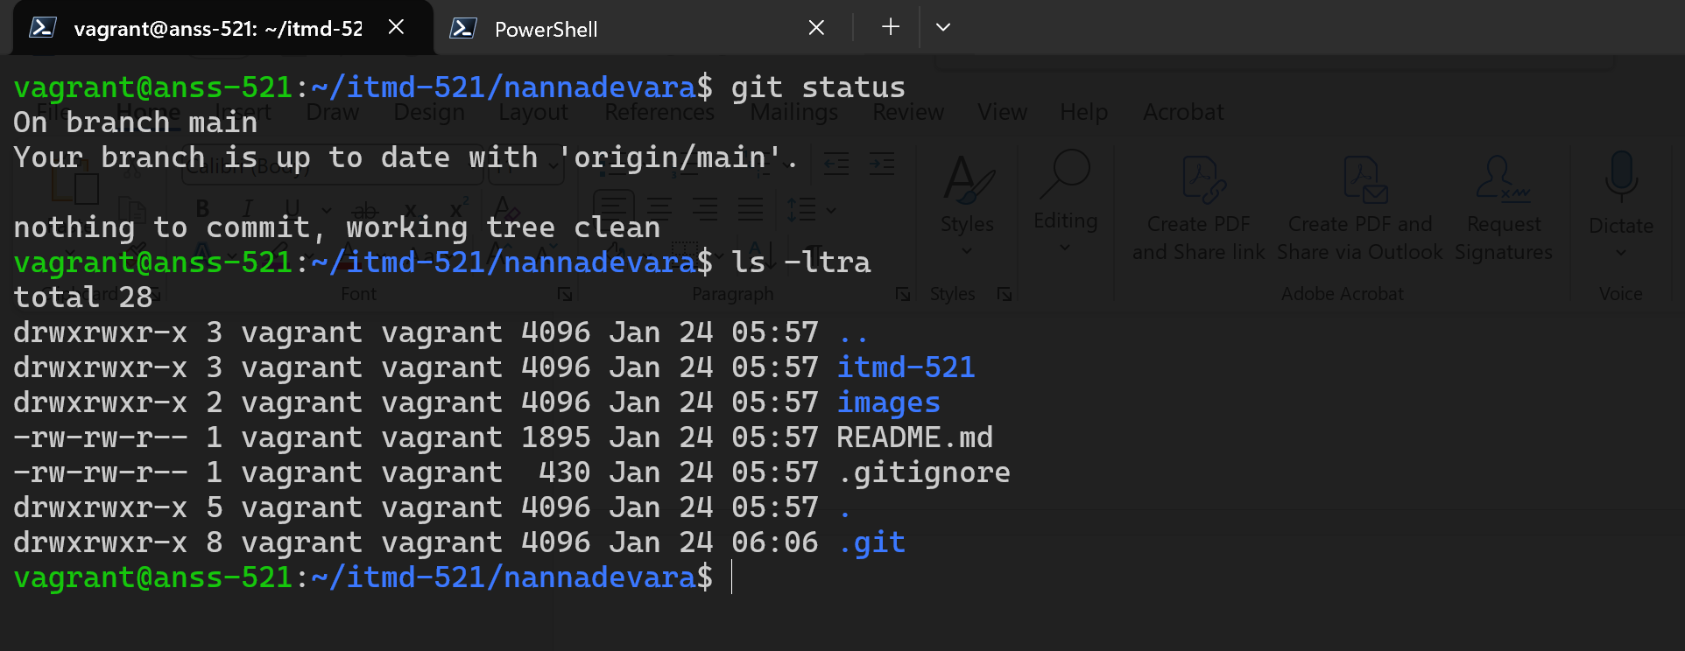

**\*\*\*\*\*\*\*\*\*\*\*\*END\*\*\*\*\*\*\*\*\*\*\*\*\*\*\*\*\***

**Result of Cloning Your Private Repository: (this is prof’s ..we should get something like this)**

**ls**

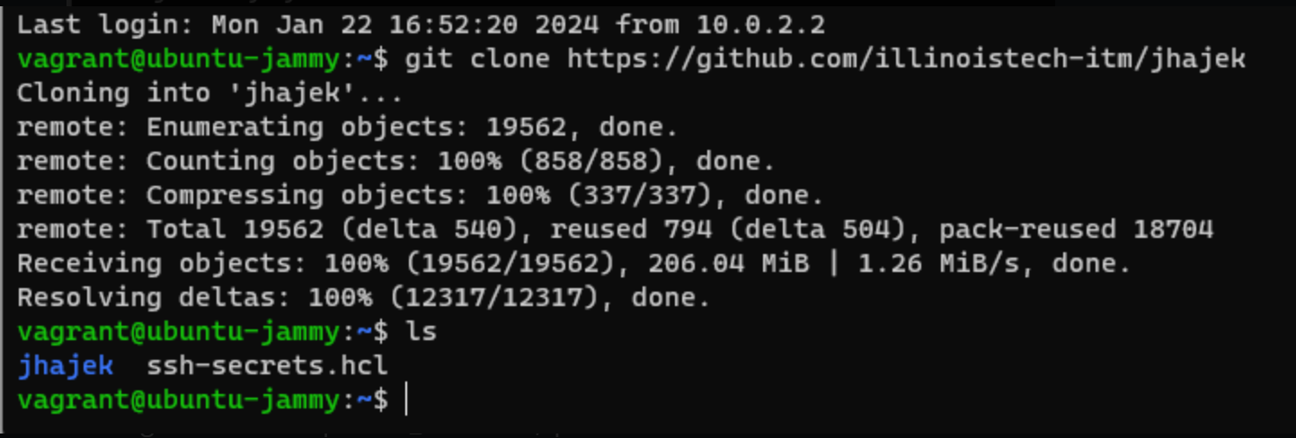

**Bash rc errors:**

